DRILLING PROPOSAL OUTLINE DOCUMENT (EXECUTIVE SUBMISSION)
CONFIDENTIAL Document Code: DPM-2026-DP-ALPHA-07
Phase: Phase 1 (Project Initiation - Gate 1 Sanction)

MAIN TABLE OF CONTENTS
- EXECUTIVE SUMMARY
- Project Mandate & Justification:
Core Energy Solution proposes the drilling of Alpha-07 Well in Alpha Field located at Central Sumatra Basin as part of its field development strategy aimed at increasing oil production through infill drilling and optimization of existing reservoirs. Alpha Field contains an estimated Original Oil in Place (OOIP) of 21.66 MMSTB and has produced approximately 6.48 MMSTB with a current water cut of around 99%, corresponding to a recovery factor of approximately 16.62%. Considering the remaining hydrocarbon potential, the proposed development seeks to maximize recovery from remaining reserves and convert existing resources into economically recoverable production. Strategically, the project supports Core Energy Solution production growth targets, promotes the optimization of mature assets through a low-risk development approach, and enhances capital efficiency by utilizing existing surface facilities and infrastructure.

- Well Classification:
The proposed Alpha-07 Well is classified as a Development Well, specifically a directional producer well with infill and step-out objectives. This classification is based on the fact that the target reservoirs (Bara, Bama, Baja, Prima sands) have been adequately defined through previous development activities, and the primary objective of the well is hydrocarbon production. The project currently consists of one directional production well utilizing a cased-hole completion design, with artificial lift support through Electric Submersible Pump (ESP) installation to maximize production performance.

- Success Criteria & KPIs:
The technical success criteria for Alpha-07 Well include successfully penetrating all target reservoirs (Bara, Bama, Baja, Prima Sands) reaching the planned total depth of approximately 5,000 ft MD, and acquiring complete subsurface data through triple combo logging, pressure test, and sidewall coring. Production objectives are initially focused on validating the remaining hydrocarbon potential through the Alpha-07 well. Subject to successful drilling and production performance, the well is expected to support the subsequent development of four additional wells. The overall development program is forecasted to deliver an incremental oil recovery of approximately 0.58 MMBO until the economic limit in 2041. Initial production rates are anticipated to range from 200 to 2,000 BFPD per well utilizing ESP artificial lift. Operational performance targets include rig moving durations of 6 days for short moves (intra field) and 14 days for long moves (inter field), a drilling duration of approximately 13,38 days followed by 1,92 days for completion activities, and a total well cycle time ranging from 21,3 to 29,3 days. Non-productive time (NPT) is targeted to remain below 5–10%, while maintaining zero Lost Time Incidents (LTI). From a cost perspective, the project targets maintaining drilling expenditures within the approved AFE budget, with a maximum allowable cost overrun of 10%. In addition, the project shall comply with Core Energy Solution and SKK Migas HSSE requirements, ensuring zero fatalities, zero major incidents, and proper waste handling through the Centralized Mud Treatment Facility (CMTF) system.

- Executive Sanction Request:
Management approval is requested to sanction the execution of the Alpha-07 drilling project and authorize the deployment of a 750 HP land rig for directional drilling operations. In addition, approval is sought for the total drilling investment of approximately USD 1.78 million and for the execution scope covering drilling and completing the well with cased-hole completion and ESP installation, as well as conducting the required logging and reservoir evaluation programs. Management is also requested to acknowledge and accept the key project risks associated with the mature nature of Alpha Field, including the existing high water cut condition of approximately 99%, potential operational challenges such as loss circulation, differential sticking, and reactive clay formations, as well as uncertainties related to reservoir performance. Approval of this proposal will enable the Project Management Team to proceed to the next phase of detailed engineering and execution planning under the Gate 1 sanction framework.

- LOCATION, GEOGRAPHY, & SURFACE RECONNAISSANCE
- Surface & Bottom-Hole Coordinates:
Alpha Field is located in the southern part of Core Energy Solution, covering an area of approximately 2 × 2 km². The proposed wells are designed as directional J-type wells with horizontal displacement 2,437 ft MD and a planned total depth of approximately 5,312 ft MD. Directional type has been selected as the preferred well architecture to minimize land acquisition requirements and mitigate surface-related constraints. This approach is driven by the existing land use and demographic conditions above the subsurface targets, which include densely populated areas, oil palm plantations, industrial forest plantations (HTI), and protected forest zones. By allowing the surface location to be placed away from sensitive areas while still accessing the target reservoirs, directional wells provide greater flexibility in well placement and reduce environmental and social impacts. In addition, directional drilling is expected to maximize reservoir contact and improve overall production recovery compared with conventional vertical wells.

Table 2.1 Surface and Subsurface Coordinate Alpha-07 Well
Parameter | X | Y | Remarks
Surface Coordinate | 748,934.38 | 110,089.99 | New Wellpad
Subsurface Coordinate | 749,434.38 | 109,589.99 | New Wellpad

- Land Acquisition & Civil Works Status:
The Alpha-07 development project requires approximately 2–2.5 ha of land to accommodate the wellpad and associated supporting facilities for a 750 HP land rig. The development concept maximizes the utilization of existing Core Energy Solution assets, while any additional land requirements will be addressed through Land Indemnification (LI) and Land Encroachment Resolution (LER) processes.

Civil and site preparation activities include wellpad construction based on a clustering concept, access road development, mud pit and rig foundation preparation for the 750 HP land rig, as well as flowline and electrical installations. Preliminary engineering and site surveys have been completed, and the wellpad layout has been optimized to accommodate future wells while minimizing flowline and power relocation requirements.

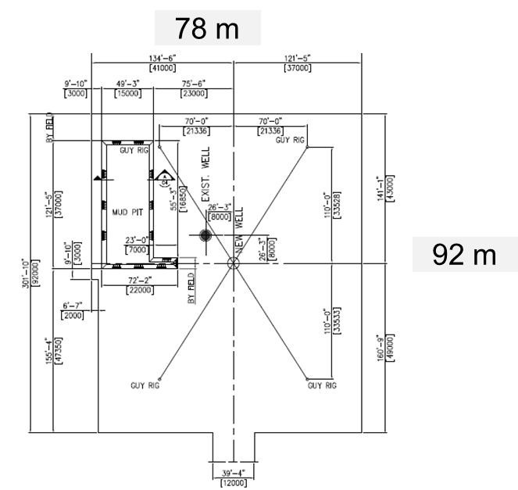
Figure 2.1 Typical Design Wellpad Rig Layout 750 HP

The project will be executed in accordance with applicable environmental and regulatory requirements, including AMDAL and UKL-UPL provisions, as well as HSSE standards established by SKK Migas. Drilling waste management will be implemented using disposal pits lined with geomembrane, followed by transportation to the Centralized Mud Treatment Facility (CMTF) for final treatment and disposal.

Permit to Drill (PTD) and other regulatory approvals are being processed as part of Project Initiation - Gate 1 Sanction process. At the time of this proposal submission, the project is progressing from Gate-1 (Project Initiation) towards Gate-2 (Detailed Engineering and Execution Preparation), with major permitting and site preparation activities proceeding according to schedule.

- Terrain & Logistics Accessibility:
Alpha Field is located in the southern part of WK Core Energy Solution in an onshore environment characterized by a combination of plantation areas, forested land, and operationally constrained zones. The terrain is generally flat, which facilitates drilling and infrastructure development. However, localized ground conditions may require additional attention during site preparation and access road construction to ensure safe and reliable operations. In addition, land accessibility and right-of-way constraints require close coordination with stakeholders to ensure uninterrupted project execution.

The Alpha-07 well will be drilled using a 750 HP land rig. Rig mobilization is estimated at approximately 6 days for intra field moves and up to 14 days for inter field mobilization. Existing roads and access routes will be upgraded as necessary to accommodate heavy-load transportation, while road crossings and associated civil structures will be designed in accordance with applicable API and ASME requirements.

- SUBSURFACE GEOLOGICAL PROGNOSIS (G&G DATA)
- Geological Target & Structural Top:
Alpha-07 is planned to develop the remaining hydrocarbon potential within the Alpha Field by targeting multiple sandstone reservoirs identified from previous development activities. The primary objectives are the Bara, Bama, Baja, Prima sands, which have demonstrated hydrocarbon productivity and favorable reservoir characteristics. Structural interpretation indicates that the targeted reservoirs are laterally continuous and located within the proven hydrocarbon-bearing interval of the field.

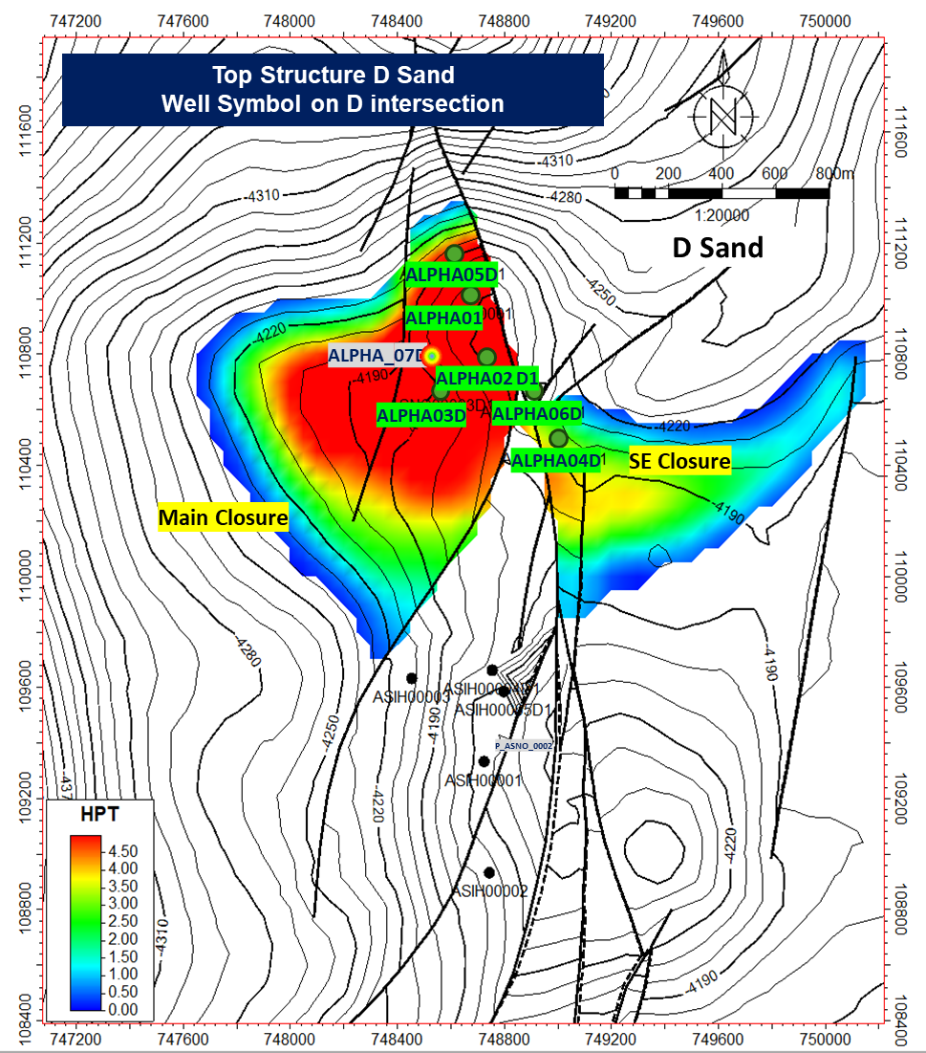
Figure 3.1 Alpha Field Proposed Development Well Location Map

- Geological Target & Structural Top:
Based on offset well data and geological interpretation, the prognosed stratigraphic sequence in Alpha Field is characterized by clastic sedimentary formations typical of the Central Sumatra Basin. From surface to total depth, the well is expected to penetrate the A and B Formation, which is predominantly composed of shale with minor sandstone interbeds. The primary hydrocarbon bearing reservoirs are associated with the Bara, Bama, Baja, Prima formations, which are characterized by sandstone sequences interbedded with shale layers. These shale intervals act as natural barriers between reservoir units and provide important considerations for well construction and drilling fluid design. The predicted lithological succession from surface to total depth is summarized below.

Table 3.1 Reservoir Target Alpha-07
Formation | Lithology | Interval Depth (ftTVD) | Subsurface Drilling Hazard Remarks
Surface | Soft & Clay | 0-2487 | No Issue
Arya | Shale | 2487-3460 | Sloughing shale, Gumbo, Tight hole
Buana | Sandstone | 3460-4042 | Sloughing shale, Gumbo, Tight hole
Bara | Sandstone | 4042-4238 | Loss Circulation, Tool Stop
Bama | Sandstone | 4238-4367 | Loss Circulation
Raja | Sandstone | 4367-4527 | Loss Circulation
Prima | Sandstone | 4527-4676 | Loss Circulation

- Hydrocarbon Potential & Reservoir Fluid Characteristics:
Reservoir evaluation and offset well analysis indicate that the Alpha-07 well contains remaining hydrocarbon potential within the Bara, Bama, Baja, Prima reservoir intervals. Among the identified sand markers, the primary reservoir targets comprise T_Bara1, T_Bama2, T_Raja1, T_Raja3, T_Raja5, and T_Prima1, which are interpreted to contain movable hydrocarbons. The expected reservoir fluid is predominantly oil, while T_Bama2 is interpreted to contain an oil and gas mixture. Several non-target intervals are expected to be water-bearing or may contain residual hydrocarbons, reflecting the mature nature of the field and associated reservoir uncertainties. Based on current subsurface interpretation, no significant sour gas concentration is anticipated and H₂S content is expected to be negligible, while CO₂ concentration is projected to remain within acceptable operating limits. The hydrocarbon distribution by reservoir interval is summarized below.

Table 3.2 Fluid Content Alpha-07
Formation | Sand Marker | Reservoir Target | Estimated Fluid Content
Surface | - | No | Water
Arya | T_Arya1 | No | Water
Arya | T_Arya1 | No | Water
Buana | T_Buana1 | No | Water
Buana | T_Buana2 | No | Possible Water
Buana | T_Buana3 | No | Possible Water
Buana | T_Buana4 | No | Possible Water
Buana | T_Buana5 | No | Water
Bara | T_Bara1 | Yes | Oil
Bara | T_Bara2 | No | Oil
Bara | T_Bara3 | No | Water
Bara | T_Bara4 | No | Water
Bara | T_Bara5 | No | Oil
Bara | T_Bara6 | No | Water
Bama | T_Bama1 | No | Possible Water
Bama | T_Bama2 | Yes | Oil & Gas
Bama | T_Bama3 | No | Possible Water
Bama | T_Bama4 | No | Water
Bama | T_Bama5 | No | Oil
Bama | T_Bama6 | No | Possible Water
Raja | T_Raja1 | Yes | Oil
Raja | T_Raja2 | No | Possible Water
Raja | T_Raja3 | Yes | Oil
Raja | T_Raja4 | No | Water
Raja | T_Raja5 | Yes | Oil
Prima | T_Prima1 | Yes | Oil
Prima | T_Prima2 | No | Water
Prima | T_Prima3 | No | Water
Basement | T_BSM | No | Water

- OFFSET WELL ANALYSIS & LESSONS LEARNED:
- Offset Wells Performance Review:
The drilling and completion strategy for the proposed Alpha-07 well has been established based on the review of offset wells, Alpha-01, Alpha-02, Alpha-03, Alpha-05, and Alpha-06. These wells were successfully drilled as vertical and directional producers targeting the Bara, Bama, Baja, Prima reservoir intervals and provide the primary basis for trajectory design, drilling performance expectations, casing setting depths, and completion philosophy.

Table 4.1 Offset Well Review Summary Alpha 01-03
OFFSET WELL REVIEW SUMMARY
Well Name | Alpha 00001 (O-O-44) Spudded in @00:00, 23 May 2000 | Alpha 00002 (O-O-64) Spudded in @01:00, 30 Oct 2000 | Alpha 00003 (O-O-74) Spudded in @15:00, 01 Jun 2008
Casing Design | 24; 9 5/8; 7 (2-Section) | 24; 9 5/8; 7 (2-Section) | 9 5/8; 7 (2-Section)
Well Type | SOW (Vertical) | DOW (S-Type) | DOW (J-Type)
Surface | 9-5/8", 36 ppf, K-55, LTC | 9-5/8", 36ppf, K-55, LTC | 9-5/8", 36 ppf, K-55, BTC
Drilling Depth/Casing Depth | 1496/1469 | 1230/1225 | 1240/1233
Cementing Type | Cmt'd csg by Hallco w/ 123 sks cmt. Displ w/ 12 BM. FDP 496 psi. Bumped plug w/ 1200 psi float held full circ, had 10 bbls contamination cmt return, CIP @ 03.30 hr. On date 25/05/2000 | Cmt'd csg w/ 108 sxs cmt. Recipr 5'-8'. Full circ. Displ w/ 92 bw. Had cmt contamination return. CIP at 12:00 hrs. Checked cmt in annulus (2' below GL) | CMTG JOB BY DOWELL. TESTED LINE 2000 PSI, PUMPED 10 BBLS WATER SPACER, FOLLOWED BY 234 BBLS 13.5 PPG LEAD SLURRY (768 SXS, 324%% X/S) + 47 BBLS 15.8 PPG TAIL SLURRY (264 SXS, 180%% X/S), DROPPED TOP PLUG, DISPLACED WITH 94 BBLS OF MUD, FULL CIRC BUT NO CMT RETURN, FP = 330 PSI, FLOAT HELD, FLUID STATIC, CIP @ 13:50, 2-JUNE-2008. RECIPROCATED CSG DURING CMTG JOB. R/D CMTG EQMT.
Cement Return | Got 10 bbls cement return on surface | No Cement return on surface | No Cement return on surface
Mud Type | Water Based | Water Based | Water Based
MW | 8.8 - 9.1 | 8.8 - 9.0 | 8.7 - 9.0
K+ | 22000 | 22000 | 22000
YP | 10 - 14 | 11 - 14 | 15 - 20
BHA Type | Rotary BHA | Rotary BHA | Rotary BHA
Bit | 12-1/4”, TCB, 3X16 | 12-1/4”, TCB, 3X16 | 12.25 in, TCB, 3x15, 1x16
Bit TFA | 0,39 | 0,39 | 0,71
FIT (ppg) | 13,46 | 13,46 | 14,4
ROP (fph) | 48 | 47 | 47
Production | 7", 26 ppf, N-80, LTC | 7", 26 ppf, N-80, K-55, LTC | 7", 23 ppf, K-55, BTC
Drilling Depth/Casing Depth | 5143/4840 | 5036/5028 | 5390/5353
Cementing Type | Cmt'd 7" prod csg by Hallco w/24 sks scav cmt + 360 sks tail cmt dipls'd w/ 184 BW, FDP 717 psi. Bumped plug w/ 1500 psi - float didn't hold, holding press w/ 300 psi. Full circ designed no cmt return TOC @ 3512', RTP & RCP. CIP @ 12.30 hrs in date 04/06/2000 | Cmtng job by Hallco. Mixed & pumped w/ 528 sxs lead & 364 tail cmt + addtv. Displ'd w/ 193 bbls wtr full circ. Had 10 bbls cmt return. Bumped plug w/ 1500 psi. Float held. CIP at 02:35 hrs | CMTG JOB BY SLB. TESTED LINE TO 2500 PSI - OK. PUMPED W/ 10 BBLS WATERHEAD, FOLLOWED W/ 40 BBLS SCAVENGER 11 PPG (72 SXS) + 416 BBLS LEAD SLURRY 12.5 PPG (834 SXS, 30% X/S)+ 34 BBLS TAIL SLURRY 15.8 PPG (126 SXS, 20% X/S). DROPPED TOP PLUG, DISPLACED W/ 210 BW, BUMPED W/ 1800 PSI, FULL CIRC, GOT 34 BBLS 12.5 PPG CMT RETURN, CHECK FLOAT, OK. CIP @ 23:00 HRS. R/D CMT SLB.
Cement Return | No cement return on surface | Got 10 bbls cement return on surface | Got 34 bbls cement return on surface
Mud Type | Water Based | Water Based | Water Based
MW | 9.3 - 9.8 | 9.1 - 9.8 | 9.0 - 10.1
K+ | 27000 | 27000 | 27000
YP | 13 - 17 | 12 - 13 | 17 - 28
BHA Type | Rotary BHA | Rotary BHA | Steerable
Bit | 8-1/2”, TCB, 3X16 | 8-1/2” TCB, 2X16, 1X15 | 8-1/2”, TCB, 2x12  8-1/2” TCB, 1x16, 1x18
Bit TFA | 0,59 | 0,57 | 0,78
FIT (ppg) | - | - | -
ROP (fph) | 39 | 41 | 40
OFFSET WELL REVIEW SUMMARY
Well Name | Alpha 00004 (O-O-74A) Spudded in @18:00, 13 Jun 2008 | Alpha 00005 (O-O-44A) Spudded in @04:00, 29 Jun 2008 | Alpha 00006 (O-O-66) Spudded in @05:00, 17 Oct 2012
Desain Casing | 13 3/8; 9 5/8; 7 (3-Section) | 9 5/8; 7 (2-Section) | 24; 9 5/8; 7 (2-Section)
Well Type | DOW (S-Type) | DOW (J-Type) | DOW (J-Type)
Surface | 13-3/8", 54.5 ppf, K-55, BTC | 9-5/8", 36 ppf, K-55, BTC | 9-5/8", 36 ppf, K-55, BTC
Drilling Depth/Casing Depth | 1240/1237 | 1258/1245 | 1310/1300
Cementing Type | CMTG JOB BY DOWELL. TESTED LINE TO 2000 PSI - OK. PUMPED W/ 10 BW AHEAD + 544 BBLS LEAD SLURRY 12.5 PPG (1436 SXS, 330% X/S) + 70 BBLS TAIL SLURRY 15.8 PPG (378 SXS, 200% X/S). DROPPED TOP PLUG, DISPLACED W/ 188 BW, FULL CIRC, HAD 100 BBLS 12.5 PPG CMT RETURN TO SURFACE, FP WAS 370 PSI, LEFT 20 FT CMT INSIDE CSG, FLOAT HOLD, CIP @17:23 HRS ON 14-JUNE-2008. R/D DOWELL CMTG UNIT. | CMTG JOB BY DOWELL SCHL. TESTED LINE TO 2000 PSI - OK. PUMPED W/ 10 BW AHEAD + 253 BBLS LEAD SLURRY 12.5 PPG (664 SXS, 370% X/S) + 51 BBLS TAIL SLURRY 15.8 PPG (247 SXS, 200% X/S). DISPLACED W/ 95.4 BBLS MUD 9 PPG, FULL CIRC, GOT 5 BBLS TRACE CMT RETURN TO SURF 9.6 PPG, FLOAT HOLD, FP @ 240 PSI, CIP @ 22:13 HRS ON JUNE 29TH 2008. | CMTG JOB BY DOWELL. TESTED LINE W/ 2000 PSI. PUMPED 20 BBLS WTR AHEAD + 109 BBLS (120% XS OT) 13.5 PPG LEAD CMT + 63.3 BBLS (120% XS OT) 15.8 PPG TAIL CMT. WORKED CSG, DROPPED TOP PLUG AND DISPLACED W/ TTL: 98.6 BBLS MUD (GOT NO RETURN WHILE DISPLACING REACHED 85 - 92 BBLS, GOT FULL RETURN AGAIN AFTER DISPLACING REACHED 92 BBLS), GOT 4 BBLS 9 PPG MUD CONTAMINATED CMT ON RETURN. FP: 375 PSI (THEO: 355 PSI). BUMPED PLUG TO 890 PSI, FLOAT HELD. CIP @ 11:00 HRS. DISCUSSED W/DRLG SUPT. DECIDED TO CONTINUE NEXT PROGRAM. R/D DOWELL UNITS.
Excess Cement/Return | Got 100 bbls 12.5 ppg cement return on surface | Got 5 bbls 9.6 ppg cement return on surface | Got 4 bbls 9 ppg cement return on surface
Mud Type | Water Based | Water Based | Water Based
MW | 8.8 - 9.0 | 8.8- 9.0 | 8.5 - 9
K+ | 22000 | 22000 | 22000
YP | 14 | 10 - 15 | 12 - 17
BHA Type | Rotary BHA | Rotary BHA | Rotary BHA
Bit | 17-1/2”, TCB, 3x18 | 12-1/4”, TCB, 3x18 | 12-1/4”, TCB, 3x18
Bit TFA | 0,75 | 0,75 | 0,75
FIT (ppg) | 14,4 | 14,4 | 13,44
ROP (fph) | 49 | 50 | 52
Intermediate | 9-5/8", 36 ppf, K-55, BTC
Drilling Depth/Casing Depth | 3858/3857
Cementing Type | CMTG JOB BY DOWELL, TESTED LINE W/ 2500 PSI, PUMPED 10 BBLS WATER SPACER + 40 BBLS 11.0 PPG SCAV + 381 BBLS (XS 150%) 12.5 PPG LEAD CMT + 56 BBLS (XS 100%) 15.8 PPG TAIL CMT, DROPPED TOP PLUG, DISPLACED W/ 301 BBLS WTR
Excess Cement/Return | Got 80 bbls 12.5 ppg cement return on surface
Mud Type | Water Based
MW | 9.1 - 9.4
K+ | 27000
YP | 16 - 24
BHA Type | Steerable
Bit | 12-1/4”, TCB, 3x18
Bit TFA | 0,75
FIT (ppg) | 14,4
ROP (fph) | 42
Production | 7", 23 ppf, K-55, BTC | 7", 23 ppf, K-55, BTC | 7", 23 ppf, K-55, BTC
Drilling Depth/Casing Depth | 5448/5443 | 5186/5146 | 5602/5602
Cementing Type | CMTG JOB BY DOWELL, TESTED LINE TO 2500 PSI - OK, PUMPED W/ 10 BW AHEAD, FOLLOWED W/ 40 BBLS SCAVENGER 11 PPG (72 SXS)+ 147.6 BBLS LEAD SLURRY 12.5 PPG (298 SXS, 20% X/S CALIPER)+ 34 BBLS TAIL SLURRY 15.8 PPG (125 SXS, 20%X/S CALIPER), DROPPED TOP PLUG, DISPLACED W/ 211 BW, BUMPED TO 1800 PSI, FULL CIRC | CMTG JOB BY SLB. TESTED LINE TO 2500 PSI - OK. PUMPED W/ 10 BBLS WATERHEAD, FOLLOWED W/ 40 BBLS SCAVENGER 11 PPG (72 SXS) + 400 BBLS LEAD SLURRY 12.5 PPG (805 SXS, 450% X/S THEO)+ 40 BBLS TAIL SLURRY 15.8 PPG (147 SXS, 35% X/S THEO). DROPPED TOP PLUG, DISPLACED W/ 200 BW, BUMPED W/ 1700 PSI, FULL CIRC, GOT 15 BBLS 12.2 PPG CMT RETURN, CHECK FLOAT, OK. CIP @ 05:50 HRS ON JULY 12,2008 | CMTG JOB BY DOWELL. TESTED LINE W/ 2500 PSI. PUMPED 40 BBLS 11 PPG SCAV + 300 BBLS (300% XS OT) 12.5 PPG LEAD CMT + 47 BBLS (40% XS OT) 15.8 PPG TAIL CMT. WORKED CSG, DROPPED TOP PLUG AND DISPLACED W/ 219 BW, FULL CIRC, GOT 140 BBLS 12.5 PPG CMT RETURN. FP: 1300 PSI. BUMPED PLUG TO 1800 PSI, FLOAT HELD. CIP @ 17:00 HRS.
Excess Cement/Return | Got 3 bbls 11.7 ppg cement return on surface | Got 15 bbls 12.2 ppg cement return on surface | Got 140 bbls 12.5 ppg cement return on surface
Mud Type | Water Based | Water Based | Water Based
MW | 9.0 - 9.3 | 9.1 - 10.7 | 9.0 - 9.6
K+ | 27000 | 27000 | 27000
YP | 20 - 28 | 25 - 30 | 18 - 31
BHA Type | Steerable | Steerable & Coring | Steerable
Bit | 8-1/2”, PDC, 619, 6x12 | 8-1/2”, PDC, 619, 6x12 | 8-1/2”, PDC, 513, 7x12
Bit TFA | 0,945 | 0,8 | 0,77
FIT (ppg) | - | - | -
ROP (fph) | 45 | 46 | 47

- Historical Drilling Events & NPT Audit:
A review of offset wells identified several recurring drilling issues that contributed to non-productive time (NPT). These historical events provide valuable lessons for mitigating risks in the proposed well.

Table 4.3 Offset Well Problem Alpha 01-03
OFFSET WELL REVIEW PROBLEM | SURFACE: NORMAL OPERATION  PRODUCTION: NO CMT RETURN, PACK-OFF, SWABBING, TAGGED, HI-TORQUE | SURFACE: NO CMT RETURN  PRODUCTION: GUMBO, TIGHT SPOT, TOOL STOP | SURFACE: NO CMT RETURN  PRODUCTION: TOOL STOP, TAGGED, HI-TORQUE, OVERPULL
Well Name | Alpha 00001 (O-O-44) Spudded in @00:00, 23 May 2000 | Alpha 00002 (O-O-64) Spudded in @01:00, 30 Oct 2000 | Alpha 00003 (O-O-74) Spudded in @15:00, 01 Jun 2008
Surface
Wellbore Problem | - | -
Intermediate
Wellbore Problem | - | - | -
Production
Wellbore Problem | - Drilling f/2548’-3283’ had no return. Circ’d and worked pipe, no return, suspected hole pack off  - POOH to 2642’, circ’d and worked on pipe 2642’ still swabbing.  - RIH w/ bit #3 tagged @2955', wash down f/2955-3283’  - Drilling f/4240' to 4518'. Hi-torque. Decided to POOH, CHC | - After wiper trip from 1404'-3286' MD due to bit is run 31 hrs. Circ out Gumbo (2 November 2000)  - While wiper trip to 3700' MD, got tight spot @3996' MD, washed down f/3996' to 4038' MD (6 November 2000)  - While run #2 CST tool stop @1410' MD (7 November 2000)  - While run #RFT tool stop @1410' MD (7 November 2000)  - RIH w/ 8-1/2" H.O. to 4900' tight hole, BS @ 3000' & 4000' (8 November 2000) | - R/U SCHL. LOGGING UNIT. RUN #1 : PEX-HALS. TOOL STOPPED @ 5100'. POOH & TRIED TO GO DOWN, GOT TOOL STOPPED @ 5065' (TOP SAND TARGET @ 4200' & BOTTOM SAND TARGET @ 4700'). POOH & LOGGED UP. DISCUSSED W/ GEOLOGIST, DECIDED TO DO WIPER TRIP. R/D SCHL. LOG TOOLS. (7 June 2008)  - WHILE LOWERING BIT TO BOTTOM FOR REAMED AND WASH DOWN , TAGGED @5316' MD (7 June 2008)  - CONT'D CONT'D RIH BIT TO BOTTOM, TAG @ 5330'. P/U KELLY. REAMED DOWN F/ 5330' TO 5390'. (10 June 2008)  - RIH W/ BHA # 3 TO BOTTOM, TAGGED 5354'. P/U KELLY. REAMED DOWN AND GOT HIGH TORQUE & OVER PULL TO 50 KLBS. CIRC HOLE CLEAN & SWEPT HI-VIS WHILE DISCUSSED W/ TM & DE AND DECIDED DEPTH WOULD BE CSG POINT. (10 June 2008)  - RIH W/ T0TAL 138 JTS R3 + 1 JT R1 7", 23#, K-55, BTC CASING. CASING STOP @ 5332'.
OFFSET WELL REVIEW PROBLEM | SURFACE: NORMAL OPERATION  INTERMEDIATE: TAG, DRAG, OVERPULL  PRODUCTION: DRAG, TIGHT SPOT, TOOL STOP | SURFACE: NORMAL OPERATION  PRODUCTION: TAG, DRAG, CASING STOP, TOOL STOP, SLOUGHING, TIGHT SPOT, HARD FORMATION | SURFACE: NORMAL OPERATION  PRODUCTION: HARD FORMATION, DRAG
Well Name | Alpha 00004 (O-O-74A) Spudded in @18:00, 13 Jun 2008 | Alpha 00005 (O-O-44A) Spudded in @04:00, 29 Jun 2008 | Alpha 00006 (O-O-66) Spudded in @05:00, 17 Oct 2012
Surface
Wellbore Problem | - | - | -
Intermediate
Wellbore Problem | - While lower bit to bottom, stopped at 2623' MD, Reamed down f/2623'-2685' MD (17 June 2008)  - While POH bit to 2600' MD, found drag @3659' w/50 klbs & 3638' w/45 klbs overpull (19 June 2008)  - Lowered bit to bottom tagged @3310', 3325', 3372' MD, Washed down f/3310' to 3350' and reamed f/3350' to 3414', cont'd lowering to bottom, tagged @3786' (19 June 2008)  - While RIH 9-5/8" CSG, got tag @3784', installed casing swage, wash down f/3784'-3857' (20 June 2008) | - | -
Production
Wellbore Problem | - While POOH bit to casing shoe due to high drag up (60 klb) (24 June 2008)  - HARD TO RUN THE TOOL AT SOME SPOTS: 4390', 5168' & 5244'. GOT HIGH TENSION (8000 LBS) WHEN LOGGING UP AT THAT POINT (NORMAL LOG UP TENSION = 6000 LBS) (25 June 2008) | - While run coring bit #1, bit tagged @3856' MD, reamed and washed down f/3854'-3874' (4 July 2008)  - Got tagged @4197' while run bit to bottom, reamed and washed down f/4197'-4223' (5 July 2008)  - While run coring bit #2, bit tagged @4467' MD, reamed and washed down f/4467'-4516' (6 July 2008)  - Got hard formation while drilling @4728'-4918', 5109'-5186') (7 July 2008)  - Got slouhging after CHC, increased MW f/9.1-9.8 ppg, spotted hi-vis and POOH bit (7 July 2008)  - RUN LOGGING #1 : TRIPLE COMBO, LOGGING STOPPED @ 1345', ATTEMPT TO RE-RIH W/ MAX SPEED BUT STILL STOPPED AT THE SAME DEPTH (NO OVERPULL WHEN PULLING). DISCCUSSED W/ DRILLING TEAM ON RIGSITE & HLS, DECIDED TO MAKE SHORTER TOOL (JUST GAMMA - - RAY AND RESISTIVITY) & RE-RIH IT. TRIED SEVERAL TIMES UNTIL MAX SPEED BUT UNSUCCESS (STILL STOPPED AT THE SAME DEPTH), DECIDED TRIP BIT TO BTTM. L/D LOGGING TOOLS. (8 July 2008)  - M/U & RIH 8-1/2" TRICONE BIT ON BHA # 5 & TAGGED @ 1342' AND WASHED REAMED F/ 1342' TO 1432' (GOT A LOT OF CUTTING). LOWERED BIT AND TAGGED @ 2712' AND WASHED DOWN F/ 2712' TO 2768'. CONT'D LOWERED BIT TO BOTTOM (3400') (8 July 2008)  - CONT'D RIH W/ 8-1/2" RR-BIT, TAG @ 5117'. P/U KELLY. WASHED & REAMED DOWN TO 5186'. (8 July 2008)  - R/U TOOLS. RE-RUN LOGGING #1 : TRIPLE COMBO, LOGGING STOPPED @ 1743', ATTEMPT TO RE-RIH W/ MAX SPEED BUT STILL STOPPED AT THE SAME DEPTH (NO OVERPULL WHEN PULLING). DISCUSSED W/ DRILLING TEAM, GEOLOGIST & HLS, DECIDED TO TRIP W/ BIT TO BTTM & INCREASE MW TO 10.0 PPG. L/D LOGGING TOOLS. (9 July 2008)  - M/U & RIH 8-1/2" TRICONE BIT ON BHA #5 & TAGGED @ 1743'. P/U KELLY. WASHED & REAMED DOWN F/ 1743' TO 1833' (GOT ALOT OF CUTTING). CONT'D LOWERED BIT, TAG @ 2012'. (9 July 2008)  - CONT'D LOWER BIT TO BOTTOM, TAG @ 5127' P/U KELLY & WASHED DOWN F/ 5127' - 5186'. (9 July 2008)  - CIRC 2 X BOTTOM UP. CONTINUOUSLY FOUND A BIT SLOUGHING SHALE CUTTING OVER SHAKER (1-2" LENGHT BY 1/3" WIDTH). (10 July 2008)  - R/U TOOLS. RE-RUN LOGGING #1 : TRIPLE COMBO, LOGGING STOPPED @ 3220', ATTEMPT TO RE-RIH W/ MAX SPEED BUT STILL STOPPED AT THE SAME DEPTH (NO OVERPULL WHEN PULLING). DISCUSSED W/ DRILLING TEAM, GEOLOGIST & HLS, DECIDED TO LOG UP F/ 3220' TO CASING SHOE & THEN RUN CASING. L/D LOGGING TOOLS. (10 July 2025)  - RIH W/8-1/2" RR BIT TO BOTTOM,BROKE CIRC AT SHOE , FILLED PIPE @ 2240'BIT TAG AT 3214' AND WASHED DOWN (10 July 2025)  - CONT'D LOWER BIT TO BOTTOM AND WASHED DOWN AT TIGHT SPOT (3228'- 3292' AND 5158'-5186') (11 July 2025)  - INSTALLED CSG SWAGE, CIRC, LOWER TO BOTTOM, CSG STOP AT 5157', CANNOT GO DOWN, DISCUSSED W/ TM, DECIDED TO SET CSG SHOE @ 5146' AND FC @ 5095'. (11 July 2025) | - FOUND HARD FORMATION @ 3825' - 3845' MD W/ INST ROP 40 FPH. (21 October 2012)  - PJSM, POOH AND L/D ALL STRING (FOUND DRAG 40 KLBS @ 4873' - 4868', RECIPROCATED STRING-OK).(23 October 2012)

Table 4.4 NPT Event Alpha 01-06
Wellname | Legal Wellname | Job Start | UE Start Date | UE Dur (hr) | Start Depth (ftMD) | Event Type | Major Category | Detail | Description
Alpha 00006 | O-O-66 | 10/10/2012 | 10/13/2012 | 6 | 0 | NPT | WO | LOC | SWA MOVING DUE TO SLIPPERY CONDITION
Alpha 00006 | O-O-66 | 10/10/2012 | 10/15/2012 | 12,5 | 0 | NPT | WO | EQP | W/O DURABASE INSTALLATION (RIG CREW WAS DISMANTLING AND LOADING AT OLD LOCATION: LIBO S2-E5-18).
Alpha 00006 | O-O-66 | 10/10/2012 | 10/15/2012 | 1 | 0 | NPT | WO | WTHR | SWA R/U EQPMNT DUE TO HEAVY RAIN & THUNDER.
Alpha 00006 | O-O-66 | 10/10/2012 | 10/20/2012 | 6,5 | 2335 | NPT | RREQ | DW HOIST | DISMANTLED AND CHANGED OUT BRAKE BAND OF DRAWORK DUE TO BROKEN.
Alpha 00005 | O-O-44A | 6/26/2008 | 6/30/2008 | 2 | 1248 | NPT | CASING PROBLEMS | CASING PROBLEMS | CONT'D CLEANED OUT CELLAR, GOT PROBLEM THAT CELLAR WAS VERY HARD TO BE DRIED.
Alpha 00005 | O-O-44A | 6/26/2008 | 7/1/2008 | 1 | 2326 | NPT | RREQ | EQP | CIRC'D WHILE REPAIRING CROSS JOINT OF ROTARY TABLE.
Alpha 00005 | O-O-44A | 6/26/2008 | 7/8/2008 | 4 | 5186 | NPT | WP | TIGHT HOLE | RUN LOGGING #1 : TRIPLE COMBO, LOGGING STOPPED @ 1345', ATTEMPT TO RE-RIH W/ MAX SPEED BUT STILL STOPPED AT THE SAME DEPTH (NO OVERPULL WHEN PULLING). DISCCUSSED W/ DRILLING TEAM ON RIGSITE & HLS, DECIDED TO MAKE SHORTER TOOL (JUST GAMMA RAY AND RESISTIVITY) & RE-RIH IT. TRIED SEVERAL TIMES UNTIL MAX SPEED BUT UNSUCCESS (STILL STOPPED AT THE SAME DEPTH), DECIDED TRIP BIT TO BTTM. L/D LOGGING TOOLS.
Alpha 00005 | O-O-44A | 6/26/2008 | 7/8/2008 | 6,5 | 5186 | NPT | WP | TIGHT HOLE | M/U & RIH 8-1/2" TRICONE BIT ON BHA # 5 & TAGGED @ 1342' AND WASHED REAMED F/ 1342' TO 1432' (GOT A LOT OF CUTTING). LOWERED BIT AND TAGGED @ 2712' AND WASHED DOWN F/ 2712' TO 2768'. CONT'D LOWERED BIT TO BOTTOM (3400').
Alpha 00005 | O-O-44A | 6/26/2008 | 7/9/2008 | 2 | 5186 | NPT | WP | TIGHT HOLE | CONT'D RIH W/ 8-1/2" RR-BIT, TAG @ 5117'.
Alpha 00005 | O-O-44A | 6/26/2008 | 7/9/2008 | 0,5 | 5186 | NPT | WP | TIGHT HOLE | P/U KELLY. WASHED & REAMED DOWN TO 5186'.
Alpha 00005 | O-O-44A | 6/26/2008 | 7/9/2008 | 2,5 | 5186 | NPT | WP | TIGHT HOLE | CHC, SWEPT & SPOTTED HIVIS.
Alpha 00005 | O-O-44A | 6/26/2008 | 7/9/2008 | 5 | 5186 | NPT | WP | TIGHT HOLE | POOH W/ BIT TO SURFACE FOR LOGGING
Alpha 00005 | O-O-44A | 6/26/2008 | 7/9/2008 | 3 | 5186 | NPT | WP | TIGHT HOLE | R/U TOOLS. RE-RUN LOGGING #1 : TRIPLE COMBO, LOGGING STOPPED @ 1743', ATTEMPT TO RE-RIH W/ MAX SPEED BUT STILL STOPPED AT THE SAME DEPTH (NO OVERPULL WHEN PULLING). DISCUSSED W/ DRILLING TEAM, GEOLOGIST & HLS, DECIDED TO TRIP W/ BIT TO BTTM & INCREASE MW TO 10.0 PPG. L/D LOGGING TOOLS.
Alpha 00005 | O-O-44A | 6/26/2008 | 7/9/2008 | 2 | 5186 | NPT | WP | TIGHT HOLE | M/U & RIH 8-1/2" TRICONE BIT ON BHA #5 & TAGGED @ 1743'.
Alpha 00005 | O-O-44A | 6/26/2008 | 7/9/2008 | 4 | 5186 | NPT | WP | TIGHT HOLE | P/U KELLY. WASHED & REAMED DOWN F/ 1743' TO 1833' (GOT ALOT OF CUTTING).
Alpha 00005 | O-O-44A | 6/26/2008 | 7/9/2008 | 1 | 5186 | NPT | WP | TIGHT HOLE | CONT'D LOWERED BIT, TAG @ 2012'.
Alpha 00005 | O-O-44A | 6/26/2008 | 7/9/2008 | 1 | 5186 | NPT | WP | TIGHT HOLE | P/U KELLY, WASHED & REAMED DOWN F/ 2012' TO 2095'.
Alpha 00005 | O-O-44A | 6/26/2008 | 7/9/2008 | 3 | 5186 | NPT | WP | TIGHT HOLE | CONT'D LOWERED BIT TO 4838' (B/C 3200', 4200').
Alpha 00005 | O-O-44A | 6/26/2008 | 7/10/2008 | 0,5 | 5186 | NPT | WP | TIGHT HOLE | CONT'D LOWER BIT TO BOTTOM, TAG @ 5127'
Alpha 00005 | O-O-44A | 6/26/2008 | 7/10/2008 | 0,5 | 5186 | NPT | WP | TIGHT HOLE | P/U KELLY & WASHED DOWN F/ 5127' - 5186'.
Alpha 00005 | O-O-44A | 6/26/2008 | 7/10/2008 | 2 | 5186 | NPT | WP | TIGHT HOLE | CIRC COND MUD TO INCREASE MUD WEIGHT F/ 10.1 - 10.3 PPG
Alpha 00005 | O-O-44A | 6/26/2008 | 7/10/2008 | 2 | 5186 | NPT | WP | TIGHT HOLE | SWEPT HIVIS (2 TIMES) & CIRC HOLE CLEAN
Alpha 00005 | O-O-44A | 6/26/2008 | 7/10/2008 | 3 | 5186 | NPT | WP | TIGHT HOLE | POH BIT TO 2240'
Alpha 00005 | O-O-44A | 6/26/2008 | 7/10/2008 | 0,5 | 5186 | NPT | WP | TIGHT HOLE | CIRC 2 X BOTTOM UP. CONTINUOUSLY FOUND A BIT SLOUGHING SHALE CUTTING OVER SHAKER (1-2" LENGHT BY 1/3" WIDTH).
Alpha 00005 | O-O-44A | 6/26/2008 | 7/10/2008 | 1 | 5186 | NPT | WP | TIGHT HOLE | CONT'D POH BIT TO SHOE (SMOOTHLY)
Alpha 00005 | O-O-44A | 6/26/2008 | 7/10/2008 | 1,5 | 5186 | NPT | WP | TIGHT HOLE | LOWER BACK BIT TO 2800' SMOOTHLY
Alpha 00005 | O-O-44A | 6/26/2008 | 7/10/2008 | 2,5 | 5186 | NPT | WP | TIGHT HOLE | POOH BIT TO SURFACE FOR LOGGING
Alpha 00004 | O-O-74A | 6/12/2008 | 6/13/2008 | 13 | 0 | NPT | RREQ | EQP | CONT'D REPAIRING T-LINE OF DESSANDER AND CHANGED KELLY BUSHING.
Alpha 00004 | O-O-74A | 6/12/2008 | 6/14/2008 | 3 | 1240 | NPT | OTHER | OTHER | ATTEMPTED TO JETTING THE CLAY W/ WASH GUN, NO WORK. DIGGING 3 FT CLAY FROM WITHIN CELLAR BOX.
Alpha 00004 | O-O-74A | 6/12/2008 | 6/15/2008 | 4,5 | 1240 | NPT | RREQ | EQP | REPLACED BLIND RAM PISTON SEAL & REPAIRED MAIN DRUM THROTLE & REPLACED BREAK OUT & MAKE UP TONG WIRES.
Alpha 00004 | O-O-74A | 6/12/2008 | 6/17/2008 | 1 | 2685 | NPT | WP | DIR CONTRL | CIRC'D SLOW PUMP RATE W/ 2 PUMPS, GOT INCREASING PRESSURE F/ 800 PSI (BEFORE) TO 1200 PSI (SUSPECTED NOZZLE WAS PLUGGED). INCREASED PUMP TO 2 X 70 SPM, GOT PRESSURE 1900 PSI (WHEN DRILLING PRESSURE WAS 1800 PSI W/ 2 X 90 SPM). ATTEMPTED TO INCREASE PUMPS TO 2 X 80 SPM, 1 PUMP SHUT OFF. SWEPT HI-VIS AND ATTEMPTED TO PUMP AGAIN, STILL SAME PROBLEM. DISCUSSED W/ DRILLING OFFICE & DECIDED TO POOH TO CHECK BIT AND CHANGE LINER PUMP.
Alpha 00004 | O-O-74A | 6/12/2008 | 6/17/2008 | 3 | 2685 | NPT | WP | DIR CONTRL | POH BIT TO 1000' TO CHECK BIT WHILE CHANGING ALL LINER PUMPS FROM 6" TO 5.5".
Alpha 00004 | O-O-74A | 6/12/2008 | 6/17/2008 | 0,5 | 2685 | NPT | WP | DIR CONTRL | P/U KELLY AND TESTED PUMP TO 500 GPM, FOUND PRESSURE 1500 PSI (NORMALLY 950 PSI).
Alpha 00004 | O-O-74A | 6/12/2008 | 6/17/2008 | 1,5 | 2685 | NPT | WP | DIR CONTRL | CONT'D POOH, TOOK OUT MWD TOOL F/ MONEL, CHECKED MUD MOTOR CLEARANCE AND BIT, FOUND THAT 1 OF 3 NOZZLES WAS PLUGGED BY ANADRILL PDM RUBBER.
Alpha 00004 | O-O-74A | 6/12/2008 | 6/17/2008 | 1 | 2685 | NPT | WP | DIR CONTRL | L/D MUD MOTOR & STABILIZER. SECURED THE WELL WITH FOSV STAB IN ON 1 STAND OE DP.
Alpha 00004 | O-O-74A | 6/12/2008 | 6/17/2008 | 3,5 | 2685 | NPT | WP | DIR CONTRL | W/O MUD MOTOR REPLACEMENT FROM ANADRILL.
Alpha 00004 | O-O-74A | 6/12/2008 | 6/17/2008 | 3 | 2685 | NPT | WP | DIR CONTRL | P/U NEW MUD MOTOR AND M/U WITH 12-1/4" RR-BIT AND MWD ASSY ON BHA #3 (SET AKO MOTOR TO 1.5 DEG).
Alpha 00004 | O-O-74A | 6/12/2008 | 6/17/2008 | 0,5 | 2685 | NPT | WP | DIR CONTRL | SHALLOW HOLE TESTED MUD MOTOR & MWD @ 150' W/ 2X100 SPM, PRESS 750 PSI - OK.
Alpha 00004 | O-O-74A | 6/12/2008 | 6/17/2008 | 3 | 2685 | NPT | WP | DIR CONTRL | LOWER BIT TO BOTTOM, STOPPED AT 2623'.
Alpha 00004 | O-O-74A | 6/12/2008 | 6/17/2008 | 1 | 2685 | NPT | WP | DIR CONTRL | REAMED DOWN F/ 2623' - 2685'.
Alpha 00004 | O-O-74A | 6/12/2008 | 6/19/2008 | 0,5 | 3763 | NPT | RREQ | EQP | CHANGED OUT RUBBER PISTON OF PUMP #1 & #2.
Alpha 00004 | O-O-74A | 6/12/2008 | 6/23/2008 | 0,5 | 5334 | NPT | OTHER | OTHER | SWEPT W/ 20 BBL LOW VIS MUD AT 1/2' OFF BOTTOM W/ 610 GPM & ROTATED W/ MAX RPM.
Alpha 00004 | O-O-74A | 6/12/2008 | 6/24/2008 | 1 | 5349 | NPT | RREQ | EQP | POH BIT SLOWLY TO 4874' WHILE FIXING CROSS JOINT
Alpha 00004 | O-O-74A | 6/12/2008 | 6/24/2008 | 0,5 | 5349 | NPT | RREQ | EQP | LOWER BACK BIT TO BOTTOM
Alpha 00003 | O-O-74 | 5/28/2008 | 6/2/2008 | 0,5 | 1236 | NPT | CEMENTING | CEMENTING | WAITED ON DOWELL CREW MIXING CHEMICAL DUE TO CAME LATE TO LOCATION. DOWELL ARRIVED AT LOCATION @ 09.30 AM, REQUESTED TO BE ON LOCATION @ 07.00 AM.
Alpha 00003 | O-O-74 | 5/28/2008 | 6/3/2008 | 1 | 1236 | NPT | EQP | SURVEY | SHALLOW HOLE TESTED MWD, UNABLE TO GET GOOD SIGNAL, CHECK MUD PUMP AND ALL CABLE + SENSOR, FOUND PRESSURE TRANSDUCER IS NOT WORKING PROPERLY
Alpha 00003 | O-O-74 | 5/28/2008 | 6/7/2008 | 6,5 | 5390 | NPT | WP | TIGHT HOLE | M/U & RIH W/ 8-1/2" 117M TRICONE BIT (RR-1) ON BHA #3, TAGGED @ 4970'.
Alpha 00003 | O-O-74 | 5/28/2008 | 6/7/2008 | 1 | 5390 | NPT | WP | TIGHT HOLE | P/U KELLY. REAMED & WASHED DOWN F/ 4970' TO 5157'
Alpha 00003 | O-O-74 | 5/28/2008 | 6/7/2008 | 1 | 5390 | NPT | WP | TIGHT HOLE | CONT'D LOWERING BIT TO BOTTOM, TAGGED @ 5316'
Alpha 00003 | O-O-74 | 5/28/2008 | 6/7/2008 | 0,5 | 5390 | NPT | WP | TIGHT HOLE | P/U KELLY, REAMED & WASHED DOWN F/ 5316 TO 5390' (TD}
Alpha 00003 | O-O-74 | 5/28/2008 | 6/7/2008 | 2 | 5390 | NPT | WP | TIGHT HOLE | CIRC HOLE CLEAN, GRADUALLY INCREASED MW TO 10.1 PPG, SWEPT & SPOTTED 35 BBLS HIVIS
Alpha 00003 | O-O-74 | 5/28/2008 | 6/7/2008 | 2,5 | 5390 | NPT | WP | TIGHT HOLE | POOH BIT TO SURFACE FOR RE-LOGGING, BIT @ 2500'
Alpha 00003 | O-O-74 | 5/28/2008 | 6/8/2008 | 2,5 | 5390 | NPT | WP | TIGHT HOLE | CONT'D POOH BIT TO SURFACE (VERY SMOOTHLY POOH).
Alpha 00003 | O-O-74 | 5/28/2008 | 6/9/2008 | 2 | 5390 | NPT | SW | STUCK WIRELINE | ATTEMPTED TO FREE LOGGING TOOL FOR SEVERAL TIMES (UNSUCCESSFUL)
Alpha 00003 | O-O-74 | 5/28/2008 | 6/9/2008 | 1 | 5390 | NPT | SW | STUCK WIRELINE | DISCUSSED W/ TEAM & DECIDED TO FISH. CONDUCTED PRE-JOB SAFETY MEETING & PREPARED FISHING TOOLS.
Alpha 00003 | O-O-74 | 5/28/2008 | 6/9/2008 | 3 | 5390 | NPT | SW | STUCK WIRELINE | INSTALLED T-CLAMP & HANG OFF UPPER SHEAVE WHEEL ON WATER TABLE.
Alpha 00003 | O-O-74 | 5/28/2008 | 6/9/2008 | 6 | 5390 | NPT | SW | STUCK WIRELINE | RIH FISHING TOOL TO TOF, TAGGED @ 4312'. LATCHED & ENGAGED THE FISH.
Alpha 00003 | O-O-74 | 5/28/2008 | 6/9/2008 | 2 | 5390 | NPT | SW | STUCK WIRELINE | WORKED ON RELEASING STUCK LOGGING TOOL. CUT OFF WIRE LINE W/ 10 KLBS TENSION.
Alpha 00003 | O-O-74 | 5/28/2008 | 6/9/2008 | 6 | 5390 | NPT | SW | STUCK WIRELINE | POOH FISH (MR SCAN TOOL) W/ FISHING TOOL, FOUND OVERPULL 15-20 LBS. RECOVERED ALL TOOLS AT THE SURFACE.
Alpha 00003 | O-O-74 | 5/28/2008 | 6/9/2008 | 0,5 | 5390 | NPT | SW | STUCK WIRELINE | DISMANTLED FISH & FISHING TOOLS
Alpha 00002 | O-O-64 | 10/25/2000
Alpha 00001 | O-O-44 | 5/19/2000

- Preliminary PPFG Calibration Basis:
The preliminary Pressure Pore Pressure Fracture Gradient (PPFG) model for Alpha Field was established based on historical Formation Integrity Test (FIT) data, limited reservoir pressure measurements (RFT and SBHP), and geomechanical analysis using Eaton's and Matthews & Kelly's methods. Due to the scarcity of sonic logs, pressure measurements, and LOT/FIT data, the PPFG profile was calibrated using offset wells and analog fields within the Central Sumatra Basin. The model was further constrained by historical drilling performance and actual drilling reports from the last campaign conducted more than ten years ago.

Table 4.5 Alpha Field PPFG Prediction
Formation | Lithology | Mid Pore Pressure (ppg) | Minimum Fracture Gradient (ppg) | Calibration Basis
Surface | Soil & Clay | 8.66 | - | Hydrostatic assumption
Arya | Shale | 8.66 | 12.60 | Hydrostatic shale model
Buana | Sandstone | 7.97 | 11.32 | Eaton's Method
Bara | Sandstone | 6.21 | 10.21 | RFT Data
Bama | Sandstone | 6.95 | 10.35 | RFT Data
Raja | Sandstone | 6.34 | 10.24 | RFT Data
Prima | Sandstone | 6.46 | 10.67 | RFT Data

The pore pressure profile indicates hydrostatic conditions in shale intervals with an equivalent gradient of approximately 8.66 ppg, while the Alpha reservoirs exhibit subnormal pressure due to reservoir depletion. Fracture gradient prediction was performed using Eaton's method for sand intervals and Matthews & Kelly's method for shale sections. A stress regression phenomenon was observed below the Top Buana, resulting in lower fracture gradients in deeper formations.

Two fracture gradient trends were established to represent the different stress regimes above and below the Top Buana. Existing FIT data served as lower-bound calibration points for shale fracture gradients, while pore pressure predictions were constrained by available RFT and shut-in bottom-hole pressure (SBHP) measurements. Historical drilling records indicated no loss circulation events when drilling with mud weights below 10 ppg, suggesting that the estimated minimum sand fracture gradient is greater than 10 ppg. However, uncertainties remain high because most pressure measurements are outdated and data availability is limited.

- CONCEPTUAL WELL CONSTRUCTION DESIGN (PRE-BOD)
- Target Depth (TD) & Wellpath Trajectory Concept:
Alpha-07 is proposed as a directional producer well with a J-type trajectory profile. The selection of a J-type well is primarily driven by the relatively large between the surface location and the subsurface targets. Under these conditions, an S-type trajectory is considered less feasible due to the additional complexity associated with inclination build and drop sections, which may increase torque and drag, drilling risks, and operational costs.

The J-type profile provides a simpler and more efficient well path by maintaining a tangent section toward the target reservoirs after reaching the planned inclination. This trajectory configuration allows the well to effectively reach the planned subsurface targets while maintaining a smooth well profile, thereby reducing drilling complexity and supporting safe and efficient drilling operations. In addition, the selected trajectory minimizes surface constraints and land acquisition requirements, allowing optimal access to the Bara, Bama, Baja, Prima reservoir intervals while maximizing reservoir exposure and production potential.

The well is planned to reach a total measured depth of approximately 5,312 ft MD with a horizontal displacement of approximately 2,437 ft. The proposed total depth is expected to terminate near the top of the argillite basement section, consistent with the successful drilling strategy implemented in nearby offset wells.

Table 5.1 Well Trajectory Design Parameters Alpha 07

Items | Alpha-07  (J-Type)
BUR, deg | 5
KOP, ftMD | 200
EOB, ftMD | 808,2
Start Drop, ftMD | -
End of Drop, ftMD | -
Inclination, deg | 30.41
Azimuth, deg | 135
Horizontal Displacement | 2437
Surface CP, ftMD/ftTVD | 1821/1654
Production CP, ftMD/ftTVD | 5312/4664

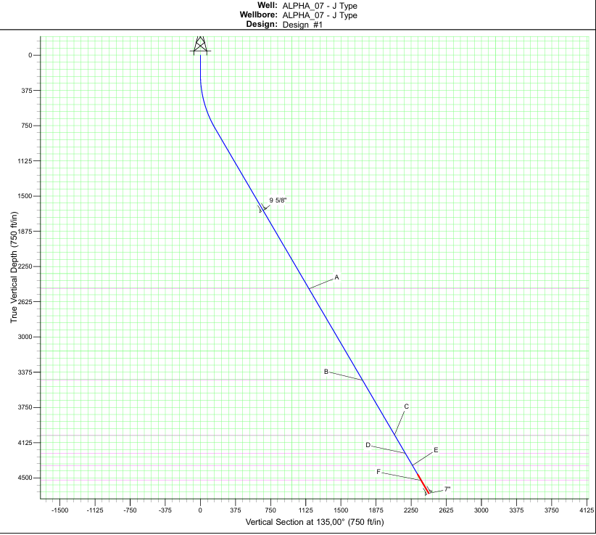
Prima
Raja
Bama
Bara
Buana
Arya
Figure 5.1 Well Trajectory Profile Alpha 07

- Conceptual Casing Program:
The casing and completion design for Alpha-07 has been developed to provide adequate well integrity, zonal isolation, and long-term production reliability. The well is designed as a cased hole producer equipped with an Electric Submersible Pump (ESP), targeting the Bara, Bama, Baja, Prima reservoir intervals. The casing setting depths and completion configuration are based on offset well experience and are intended to ensure safe drilling operations and efficient production performance.

The well architecture consists of two casing strings. A 9-5/8 in., 36 ppf, K55 BTC surface casing will be set at approximately 1,821 ft MD to isolate shallow formations and provide structural support for subsequent drilling operations. A 7 in., 23 ppf, K55 BTC production casing will be run and cemented to approximately 5,312 ft MD, covering the target reservoir intervals and providing a conduit for production and completion equipment.

The initial completion design utilizes a cased-hole configuration with selective perforations across the Bara, Bama, Baja, Prima sand reservoirs. Production is planned using an Electric Submersible Pump (ESP) system to accommodate the expected fluid production rates and high water-cut conditions. The completion assembly is designed to provide operational flexibility and facilitate future intervention and production optimization activities.

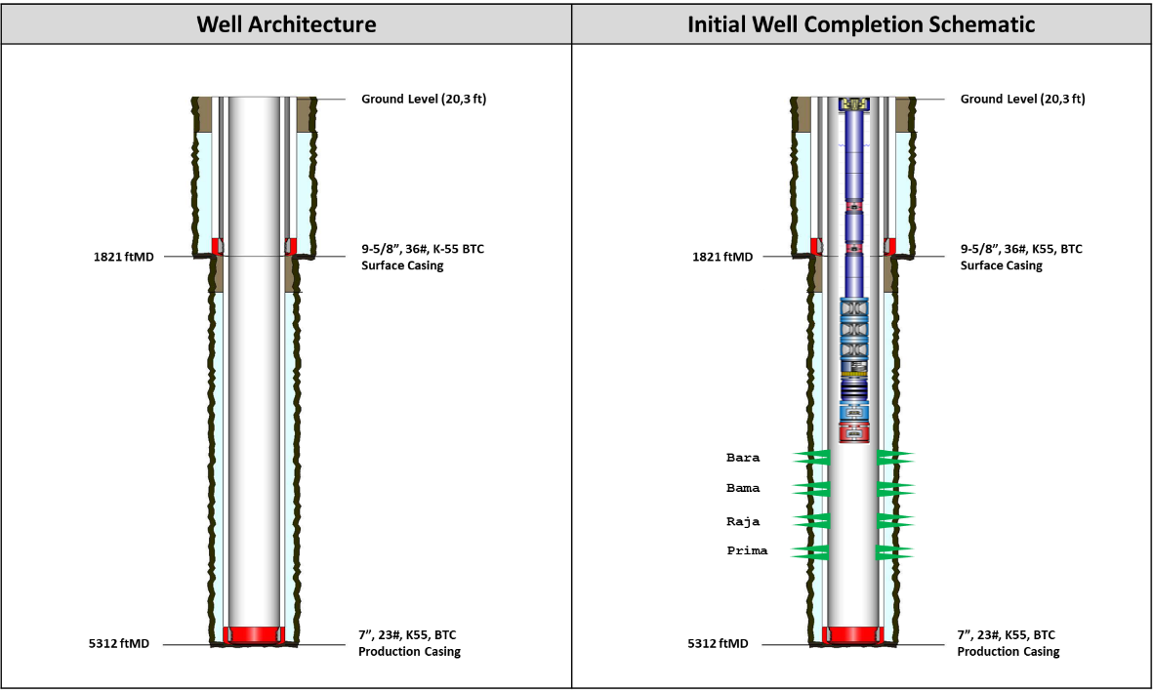
Figure 5.2 Well Architecture and Well Completion Schematic Alpha 07

- Fluids & Cementing Strategic Intent:
The fluid and cementing design strategy for Alpha well focuses on two main aspects: selecting an appropriate mud system to maintain borehole stability, and designing effective zonal isolation to ensure long-term well integrity.

Drilling Fluids
A Water-Based Mud (WBM) system with KCl-Polymer is used across all major sections. WBM was chosen over Oil-Based Mud (OBM) due to operational considerations such as shale swelling control, environmental compatibility, and ease of handling and disposal. The KCl-Polymer system is designed with a density of approximately 8.7–9.0 ppg for surface section and 9.0–9.8 ppg for production section, controlled rheology (PV/YP), and a minimum KCl concentration of 5% to inhibit clay and prevent wellbore instability during drilling, particularly in directional intervals with higher torque-drag and complex hole cleaning risks.

Cementing Strategy
A Class G cement system is applied, with an 11.0 ppg scavenger spacer to enhance mud removal efficiency. A dual slurry concept (lead & tail slurry) is implemented for 7” and 9-5/8” casing strings. Lead slurry density 12.5 ppg and Tail slurry has higher density 15.8 ppg to provide compressive strength and stronger zonal isolation in critical intervals, while the lead slurry serves as a transition to improve mud displacement.

Parameter | Surface Section (12-1/4" OH – 9-5/8" Casing) | Production Section (8-1/2" OH – 7" Casing)
Depth | 1821 ftMD | 5312 ftMD
Mud Type | WBM KCl-Polymer | WBM KCl-Polymer
Mud Weight (MW) | 8.7–9.0 ppg | 9.0–9.8 ppg
Rheology (PV/YP) | PV: ALAP, YP: 16–22 | PV: ALAP, YP: 26–30
KCl Concentration | 5% | 5%
Cement Type | Class G cement | Class G cement
Spacer | 11.0 ppg scavenger | 11.0 ppg scavenger
Slurry Design | Dual slurry: Lead 12.5 ppg, Tail 15.8 ppg | Dual slurry: Lead 12.5 ppg, Tail 15.8 ppg
Tail Cement Length | Min 200 ft above casing shoe | Min 500 ft above Bara sand
Special Additives | – | Light Weight cement + fiber if loss circulation occurs
Bump Plug | 500 psi above final circulating pressure | 500 psi above final circulating pressure
Main Objective | Stabilize shallow hole, isolate surface formations, provide mechanical support for deeper casing | Isolate reservoir (Bara sand), prevent gas migration, ensure long-term zonal isolation during production

- MINIMUM RIG SPECIFICATIONS & CRITICAL THIRD-PARTY SERVICES
- Rig Fleet Horsepower & Mast Capacity:
The rig selected for execute Alpha-07 well shall meet the following minimum hoisting and mechanical specifications to ensure safe and efficient well execution:
- Drawworks: Minimum drawworks rating of 750 HP, capable of handling a maximum hook load of 404,656 lbf, to accommodate anticipated string weights during drilling, casing running, and pulling operations.
- Mast / Substructure: Mast shall be double-stand capable with a static load capacity of 404,656 lbf. Substructure shall support a maximum combined load of 728,381 lbs, accounting for simultaneous hook load, rotary load, and setback weight.
- Block & Hook: Minimum block and hook capacity of 2,500 kN (~250 tons / 562,022 lbf) to provide adequate safety margin above maximum anticipated hook loads.
- Maximum Drilling to Pull (MDTP) has been defined for each personnel authority:
    - Driller: 80% = 323 klbs
    - Toolpusher/RSM: 90% = 363 klbs
    - Rig Superintendent: 100% = 404 klbs

- Well Control Equipment Pressure Rating:
All well control equipment installed on the rig shall meet minimum pressure ratings as defined below, in compliance with applicable well control standards and formation pressure profiles anticipated for this well:

Annular Preventer (BOP):
Minimum working pressure rating of 5,000 psi (5M), size 13-5/8", to provide primary annular sealing capability against wellbore pressure during well control events.
Blind Ram & Pipe Ram:
- Blind Ram: 13-5/8" – 5M rating, capable of fully closing and sealing the wellbore in the event of an emergency shut-in.
- Pipe Ram: 13-5/8" – 5M rating, sized and rated to seal around the drill string or casing in use.

Choke Manifold:
- Manufacturer: Chengde Kingdream Petroleum Machinery
- Minimum working pressure: 5,000 psi (5M)
- Gate valve size: 4-1/16"
- Choke line: 3" Co Flex Hose, rated for high-pressure flow management during well kill operations.
- Choke configuration: 1 (one) manual adjustable choke and 1 (one) remotely operated choke (super choke), ensuring dual operability for well control flexibility.

All BOP components, choke manifolds, and high-pressure kill/choke lines shall carry a minimum pressure rating of 5,000 psi (5M). Should the anticipated shut-in wellhead pressure (SIWHP) exceed 5,000 psi based on pore pressure prognosis, equipment shall be upgraded to a 10,000 psi (10M) rated system prior to spud, subject to well-specific engineering review and approval.

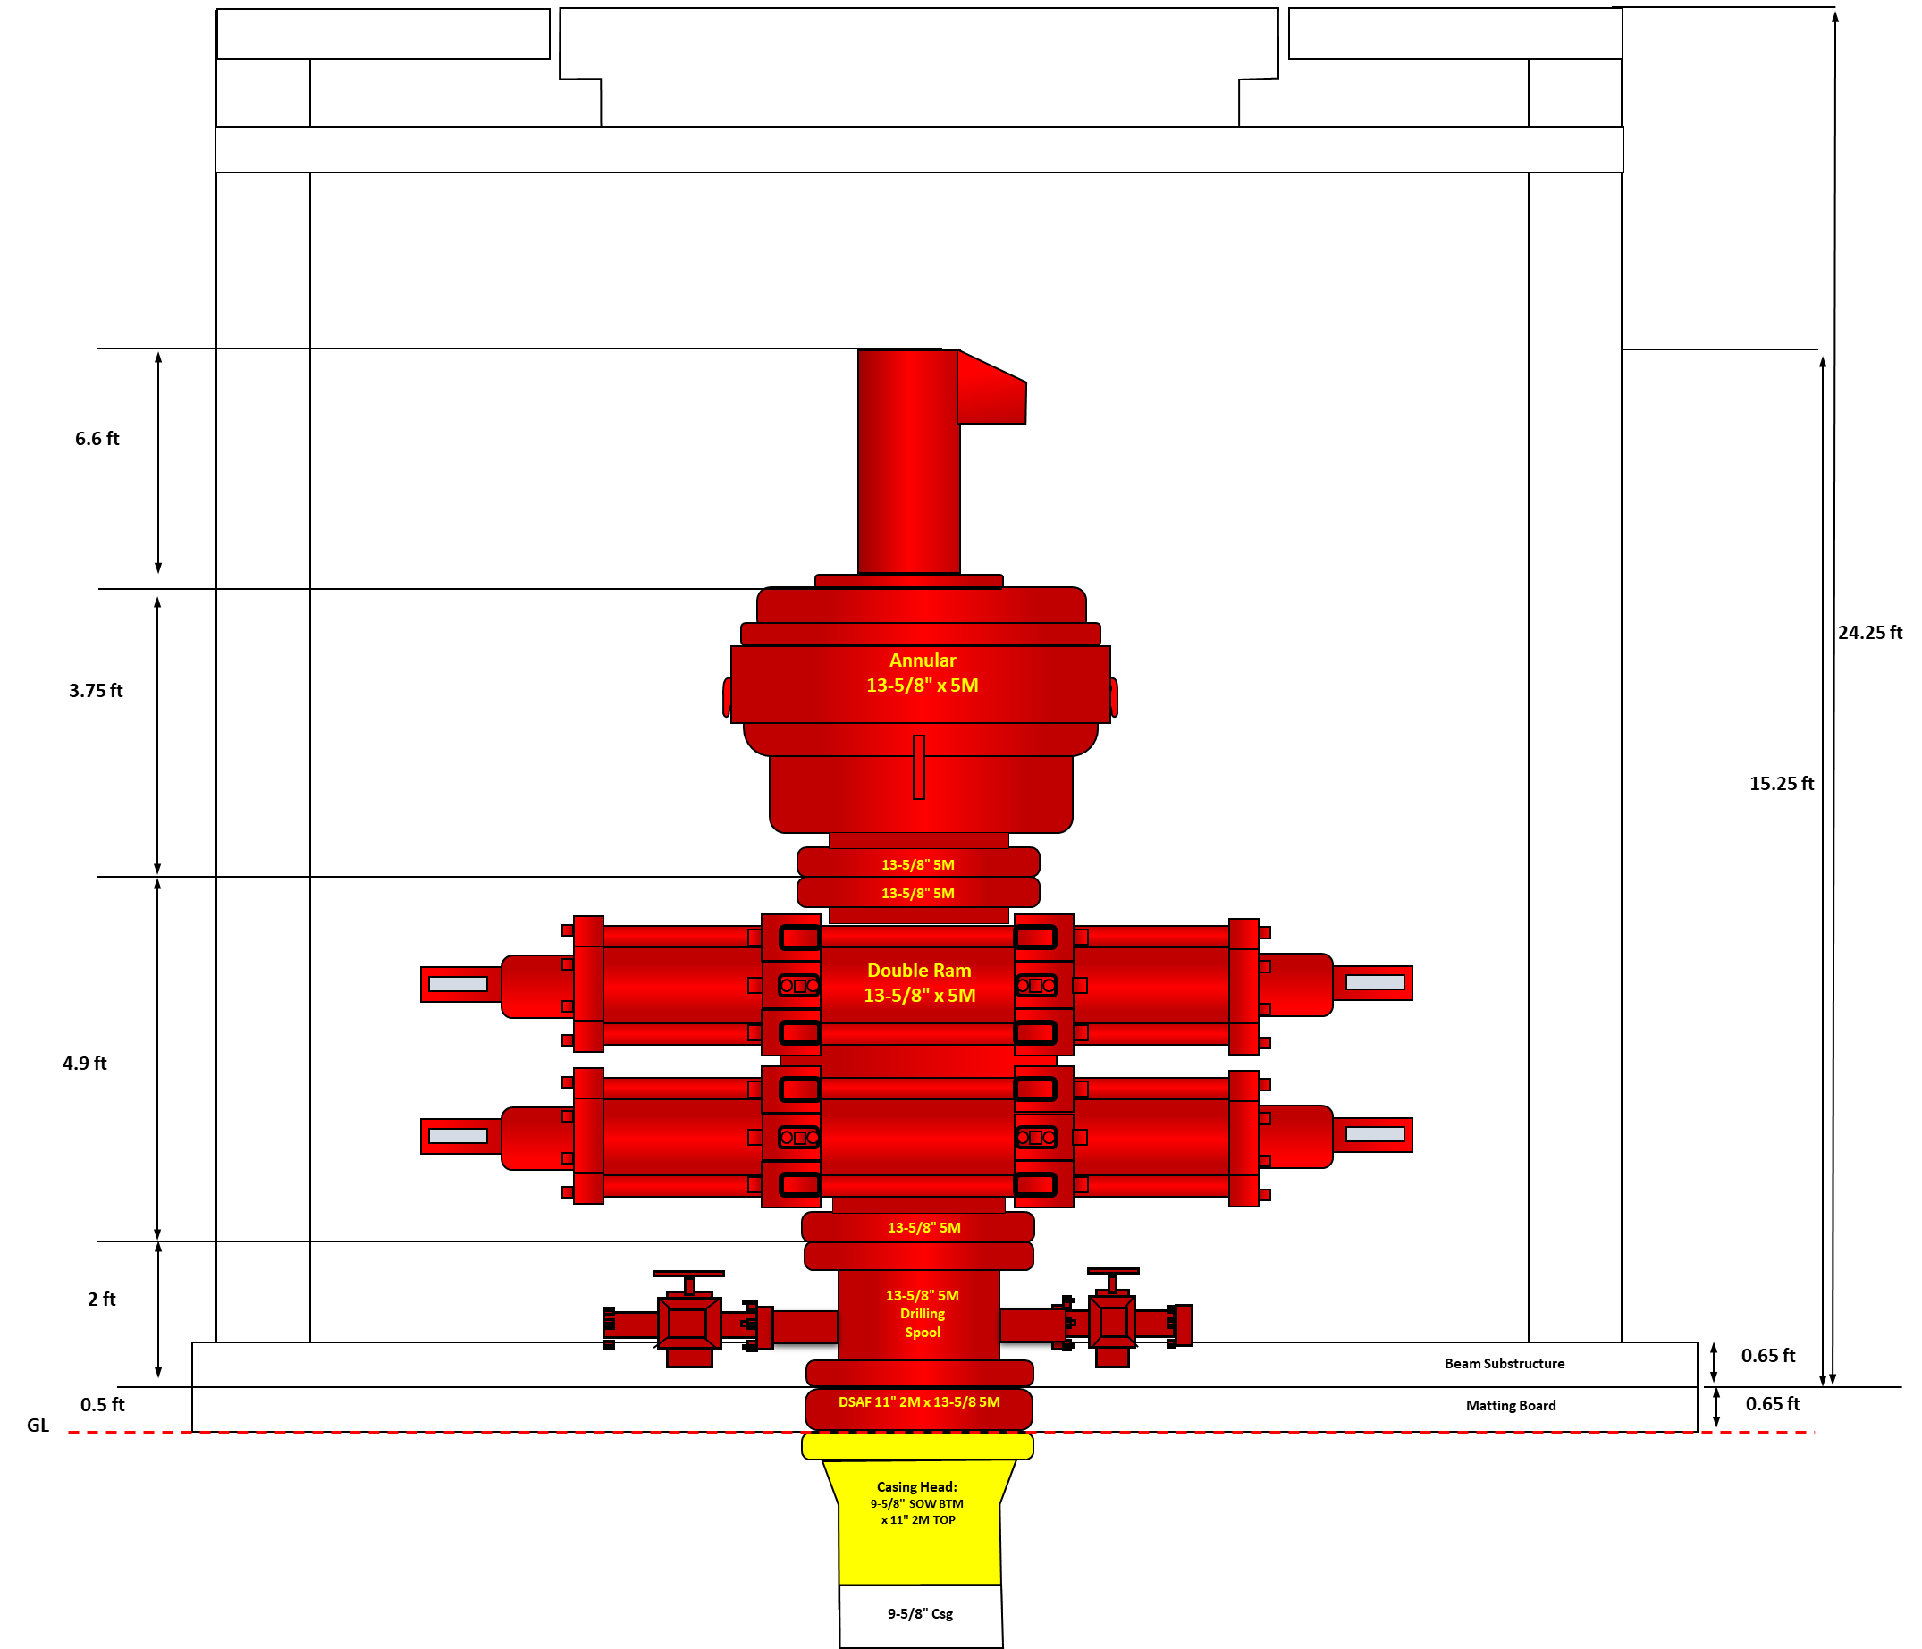
Figure 6.1 BOP Space Out Section A: Casing Head

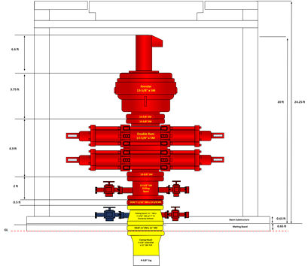
Figure 6.2 BOP Space Out Section B: Tubing Spool

Figure 6.3 Choke Manifold

- Long Lead Items (LLI) Identification:
Based on the material list for Alpha 07 well, the following items are identified as LLI:

Table 6.1 LLI Material Classification and Justification
🔴 CATEGORY 1 — Critical LLI (Lead Time > 12 Weeks)
No | Item | Specification | Qty | LLI Justification
1 | ESP Assembly | Sub-surface electrical pump | 1 EA | Custom manufactured to well specific design (reservoir depth, flow rate, GOR), typical lead time 16–24 weeks
2 | Casing 9-5/8" | K-55, 36.00 PPF, BT&C, R-3 | 48 JT | Large volume order, may require mill order if warehouse stock is insufficient
3 | Casing 7" | K-55, 23 PPF, BT&C, R-3 | 140 JT | Largest quantity item in material list, high risk of delay if not ordered in advance
4 | Tubing 3-1/2" EUE | J-55, 9.30 PPF, R-2 | 161 JT | Significant quantity delivery risk if not allocated early from pipe yard or mill
🟡 CATEGORY 2 — High Priority LLI (Lead Time 8–12 Weeks)
No | Item | Specification | Qty | LLI Justification
4 | Casing Head Assembly | 9-5/8", SOW, 2000 psi | 1 EA | Critical wellhead component, lead time 8–16 weeks depending on pressure rating and configuration
5 | Tubing Spool Assembly | 11"-2M x 7-1/16"-2M, Production | 1 EA | Surface wellhead component, must match pressure rating and bore size, not a standard stocked item
6 | Master Valve / Gate Valve | 3", 2M (2,000 psi WP) | 1 EA | Primary surface flow control valve on Xmas Tree, pressure rated and bore specific, must be procured and tested prior to well completion, Core Energy Solution supply responsibility
7 | Cable Protector ESP | 3-1/2", 3/8" Cap Tube | 161 EA | High quantity, size-specific to tubing string, not commonly available in large quantities from local stock-Core Energy Solution supply responsibility
7 | Switchboard (ESP) | Electrical control panel | 1 EA | Custom engineered per ESP specifications, lead time 8–12 weeks, must be ordered simultaneously with ESP
8 | Junction Box (ESP) | Electrical interface unit | 1 EA | Paired with ESP assembly, custom configuration required
🟢 CATEGORY 3 — Moderate LLI (Lead Time 4–8 Weeks)
No | Item | Specification | Qty | LLI Justification
7 | Float Collar & Float Shoe | K-55, 36.00 PPF, BT&C, K-55, 23 PPF, BT&C | 4 EA | Stock availability must be confirmed early to avoid last-minute substitution
8 | Pup Joints 3-1/2" | J-55, MOD EUE 8RD, various lengths (4ft, 6ft, 8ft, 10ft) | 4 JT | Nonstandard lengths, not commonly held in local inventory
9 | Bleeder Valve | 3-1/2", DWG.BE-7-ME-044 | 1 EA | May require fabrication or special order-Core Energy Solution supply responsibility
10 | Check Valve | 3-1/2", Screwed, F/TBG, J-55, EUE | 1 EA | Specific thread and material grade, availability must be confirmed against local stock-Core Energy Solution supply responsibility

- PROJECT RISK ASSESSMENT & MITIGATION MATRIX (Corrected Position)
- Subsurface Technical Risks:
The following subsurface technical risks have been identified based on offset well data analysis and formation evaluation for well Alpha 07. Risks are categorized by drilling phase and include defined engineering mitigations and contingency plans.

Table 7.1 Surface Hole Section (12-1/4") and Production Hole Section (8-1/2”) Drilling Hazards Risk and Mitigation
SURFACE HOLE SECTION (12-1/4")
No | Risk Description | Potential Impact | Mitigation / Contingency Plan | Likelihood | Consequence | Risk Rating
1 | Reactive Clay | Wellbore instability, hole enlargement, poor hole cleaning, potential stuck pipe | - Start KCl with 5% concentration and increase as per well dictate  - Follow mud properties as per approved mud program  - Ensure adequate hole cleaning practices throughout drilling | 3 | 3 | M
2 | Surface Leaking | Loss of drilling fluid to surface formation, poor cement job, inadequate shoe integrity | - Conductor has been piled as per construction standard  - Apply 300 GPM and 90 RPM or as practicable on the first 120 ftMD  - Use LCM if low loss rate is encountered Proceed with cementing plug if loss rate does not decrease or surface volume cannot be maintained | 3 | 4 | H
PRODUCTION HOLE SECTION (8-1/2")
No | Risk Description | Potential Impact | Mitigation / Contingency Plan
3 | Sloughing | Hole instability, fill on bottom, poor log quality, potential stuck pipe | - Develop mud weight vs depth log based on offset well data  - Monitor cuttings return closely to identify sloughing indication as early as possible  - Increase mud weight as per well dictate | 3 | 3 | M
4 | Loss Circulation During Drilling and/or Cementing | Partial or total fluid loss, well control risk, poor cement job, formation damage | - Monitor ECD and pump HiVis sweeps to keep hole clean and reduce ECD  - Use LCM and fiber as preventive measure  - Use LW cement for tail slurry with fiber  - Prepare for top job as per SOP | 4 | 4 | H
5 | Differential Sticking | Drill string stuck in place, fishing operation required, non-productive time (NPT) | - Maintain bridging material and ensure good fluid loss control  - Minimize pipe stationary time during connections, surveys, and other operations  - Apply stuck pipe prevention guideline  - Ensure good hole cleaning by monitoring ECD trend  - Regularly sweep HiVis if ECD increases or poor hole cleaning is indicated  - Conduct T&D monitoring throughout drilling Secure string inside casing if extended stop is anticipated due to rig or operational issues | 3 | 4 | H
6 | Casing Stop | Casing unable to reach TD, incomplete well construction, remedial operation required | - Ensure good hole cleaning practice prior to casing run  - Ensure mud properties are within specification before running casing  - Prepare casing swedge for circulation if required  - Conduct wiper trip before running casing if hole condition warrants | 3 | 3 | M
7 | Logging Stop | Logging tool unable to reach target depth, incomplete formation evaluation, loss of data | - Prepare BHA/Hole Opener for conditioning trip  - If tool still tags after trip, consider using CDO or TDL for logging job | 3 | 3 | M

- Operational & Equipment Risks:
The following risks are identified from an operational and equipment perspective for Alpha-07 Well execution. These risks are associated with rig mechanical integrity, third-party service readiness, supply chain management, and field execution capability.

Table 7.2 Operational & Equipment Risk & Mitigation
No | Risk Description | Potential Impact | Mitigation / Contingency Plan | Likelihood | Consequence | Risk Rating
1 | Rig Mechanical Failure (drawworks, mud pumps, rotary table, hoisting system) | Unplanned rig shutdown, extended NPT, potential well control risk if circulation is lost | - Conduct comprehensive pre-spud rig inspection and acceptance test for all critical mechanical systems  - Ensure all critical spare parts (brake bands, pump liners, pistons, cross joints) are available on location prior to spud  - Enforce preventive maintenance schedule throughout drilling operations | 2 | 4 | M
2 | MWD / Directional Drilling Tool Failure | Loss of directional control, trajectory deviation from planned well path, additional round trips | - Conduct shallow hole function test of MWD and mud motor assembly before drilling ahead  - Maintain backup MWD tool and mud motor within 24-hour mobilization distance  - Establish clear escalation protocol if tool signal is lost downhole | 3 | 3 | M
3 | Wireline & Logging Tool Failure / Stuck Tool | Incomplete formation evaluation, loss of critical reservoir data, potential fishing operation and additional NPT | - Ensure adequate hole conditioning and wiper trip prior to all logging runs  - Prepare contingency logging method (CDO/TDL) in the event of repeated tool stop  - Maintain fishing tool inventory on location throughout logging operations | 3 | 3 | M
4 | Third-Party Service Crew Mobilization Delay (cementing, directional drilling, logging, wireline) | Delayed critical operations, rig standby cost, schedule overrun | - Confirm all service company crew and equipment mobilization schedules minimum 48 hours before planned job execution  - Include mobilization timeline in pre-spud meeting agenda  - Establish penalty clause in service agreements for late mobilization | 2 | 3 | L
5 | Long Lead Item (LLI) Procurement Delay (casing, tubing, wellhead assembly, tubing spool, ESP electrical equipment) | Delayed spud date, inability to execute well construction on schedule, cost escalation | - Issue procurement authorization immediately upon Gate-1 sanction approval  - Track all LLI delivery milestones as part of project critical path  - Identify alternative stocking sources as backup for high-risk items | 3 | 4 | H
6 | ESP & Completion Equipment Supply Chain Disruption | Deferred production start-up, additional rig standby cost, completion schedule overrun | - Issue early commitment to ESP contractor upon project sanction  - Monitor ESP fabrication progress at key milestones (50%, 80%, and 100% completion)  - Align ESP specifications with final production engineering data before manufacturing order is placed | 3 | 4 | H
7 | Rig Mobilization Delay | Late spud, schedule overrun, increased standby costs, cascading delay to subsequent wells | - Complete all pre-mobilization road survey and civil works prior to rig move  - Confirm rig release date from previous location minimum 2 weeks ahead of planned spud  - Coordinate heavy-load transport permit and road crossing clearance in advance | 2 | 3 | L
8 | Location & Access Road Failure (soft ground, heavy rain, road damage during rig move) | Rig movement interruption, equipment damage, personnel safety risk, delayed operations | - Design wellpad and access roads per applicable load-bearing standards for 750 HP rig equipment  - Use composite matting boards at critical ground contact points  - Conduct road condition assessment before and during rig mobilization | 2 | 3 | L
9 | Non-Productive Time (NPT) Exceeding Target | Cost overrun beyond approved AFE, schedule delay impacting subsequent well program | - Set NPT target below 5–10% of total well time and monitor daily against plan Conduct daily operational performance review between Drilling Supervisor and Well Engineer  - Implement lessons learned from Alpha Field offset wells (Alpha-01 to Alpha-06) in pre-spud planning | 3 | 3 | M
10 | Key Personnel Unavailability (Drilling Supervisor, DSM Consultant, HES Consultant, Wellsite Geologist) | Operational decision-making gap, HSE compliance risk, regulatory non-conformance | - Confirm all key personnel assignments and mobilization schedule prior to spud Establish clear relief rotation schedule for extended operations  - Identify backup personnel for each critical role prior to project execution | 2 | 3 | L

- HSE, Regulatory, & Community Risks:
The following risks are identified from Health, Safety, Environment (HSE), regulatory compliance, and community relations perspectives for Alpha-07 Well execution. These risks are associated with personnel safety, environmental protection, permit compliance, and stakeholder management throughout the well lifecycle.

Table 7.3 HSE, Regulatory & Community Risk & Mitigation
No | Risk Description | Potential Impact | Mitigation / Contingency Plan | Likelihood | Consequence | Risk Rating
1 | Personal Injury / Lost Time Incident (LTI) during rig-up, drilling, and completion operations | Fatality or serious injury to personnel, operational shutdown, reputational damage, regulatory investigation | - Enforce mandatory pre-task safety meeting (JSA/STARRT card) before every critical operation  - Conduct daily safety briefing attended by all personnel on location  - Maintain zero LTI target throughout well execution; any near-miss must be reported and investigated within 24 hours | 2 | 4 | M
2 | H₂S Gas Exposure | Personnel injury or fatality, emergency evacuation, regulatory shutdown | - Deploy H₂S detection equipment on location throughout drilling and completion operations  - Conduct H₂S awareness and emergency response training for all personnel prior to spud  - Establish Muster Point and Emergency Response Plan (ERP) before spud; conduct drill at least once during operations. Note: Based on subsurface interpretation, H₂S concentration is expected to be negligible for Alpha-07 | 1 | 5 | M
3 | Well Control Incident / Blowout | Loss of well, personnel casualties, environmental contamination, major regulatory sanctions | - Ensure all well control equipment (BOP, choke manifold) is tested and certified prior to spud  - All rig crew and key personnel shall hold valid Well Control certification (IWCF/IADC)  - Conduct BOP drill minimum once per week throughout drilling operations Maintain adequate mud weight and well barriers at all times per dual barrier policy | 2 | 5 | H
4 | Drilling Fluid & Mud Waste Spillage | Soil and groundwater contamination, environmental regulatory violation, community complaint | - Install secondary containment (lined mud pits with geomembrane) for all drilling fluid systems  - Transport all drilling waste to Centralized Mud Treatment Facility (CMTF) for proper treatment and disposal  - Conduct daily inspection of all mud pit liners and containment berms | 3 | 3 | M
5 | Produced Water & Hydrocarbon Spill During Well Testing / Completion | Surface soil and water contamination, flora and fauna impact, regulatory penalty | - Deploy oil boom and spill containment kit on location prior to well test operations  - Conduct pre-job inspection of all flowline connections, valves, and surface test equipment  - Ensure flare pit is properly lined and positioned downwind from personnel areas | 2 | 4 | M
6 | Permit to Drill (PTD) Delay or Non-Compliance | Inability to spud on planned date, regulatory sanction, project schedule overrun | - Initiate PTD application process in parallel with detailed engineering as part of Gate-1 to Gate-2 transition  - Maintain active coordination with SKK Migas and relevant regulatory bodies throughout permitting process  - Ensure all supporting documents (well design, environmental clearance, land status) are complete prior to PTD submission | 3 | 3 | M
7 | AMDAL / UKL-UPL Environmental Permit Non-Compliance | Regulatory shutdown, financial penalty, reputational damage to Core Energy Solution | - Ensure AMDAL or UKL-UPL document is approved and valid prior to any site preparation or drilling activity  - Conduct environmental monitoring (air quality, noise level, water quality) throughout operations as per permit requirements  - Assign dedicated environmental officer to monitor compliance on location | 2 | 4 | M
8 | Land Acquisition Dispute (LI/LER Process) | Delayed wellpad construction, community conflict, legal dispute, project schedule overrun | - Conduct early engagement with landowners and affected communities through formal Land Indemnification (LI) and Land Encroachment Resolution (LER) processes  - Involve local government representatives in land negotiation process  - Document all land agreements formally before mobilizing civil works contractor | 3 | 3 | M
9 | Community Disturbance & Social Conflict (noise, dust, traffic, land use concerns from local residents, plantation workers, and forest area stakeholders) | Operational disruption, forced work stoppage, reputational risk, escalation to regulatory bodies | - Conduct community socialization meeting before mobilization and site preparation activities  - Establish formal community grievance mechanism and designate a Community Liaison Officer (CLO) on location Maintain open communication with local village leaders and government throughout project execution | 2 | 3 | L
10 | Heavy Equipment Traffic Accident During Rig Mobilization (involving local community roads and public users) | Personnel or public fatality, property damage, legal liability, project delay | - Conduct pre-mobilization road survey and obtain necessary transport permits for oversized loads  - Deploy traffic management team and flagmen during rig move on public roads Conduct pre-move safety briefing for all transport drivers and escort personnel | 2 | 4 | M
11 | Wildfire / Peat Fire Risk (Central Sumatra onshore environment) | Asset damage, personnel evacuation, environmental violation, operational shutdown | - Conduct fire risk assessment prior to site preparation and throughout dry season operations  - Prohibit open burning on and around wellpad at all times  - Maintain fire extinguishers and firefighting equipment on location; conduct fire drill prior to spud | 2 | 4 | M
12 | Waste Management Non-Compliance (drill cuttings, chemical waste, domestic waste) | Environmental contamination, regulatory penalty, community complaint | - Implement waste segregation at source (hazardous vs. non-hazardous) across all waste streams on location  - Ensure all hazardous waste is handled by licensed waste transporter and disposed at approved facility  - Maintain waste manifest documentation for all waste movements off location | 2 | 3 | L

Table 7.4 Risk Rating Summary
Risk Rating | 7.1 Subsurface | 7.2 Operational | 7.3 HSE & Regulatory | Total
🔴 E (Extreme) | 0 | 0 | 0 | 0
🟠 H (High) | 3 | 3 | 1 | 7
🟡 M (Medium) | 4 | 4 | 9 | 17
🟢 L (Low) | 0 | 3 | 2 | 5
Total | 7 | 10 | 12 | 29

- Risk Mitigation Cost Impact:
Contingency costs are defined as additional expenditures that may be incurred if identified risks materialize during well execution. The overall contingency allowance is targeted at a maximum of 10% of total AFE value, consistent with the project cost overrun tolerance defined in the Success Criteria. Contingency costs are categorized into three risk domains aligned with Sections A through C.

Table 7.4 Risk Mitigation Cost Impact
No | Risk Source | Risk Event | Mitigation Activity | Cost Driver | Cost Category
A - Subsurface Technical Risks
1 | Reactive Clay (Surface Section) | Hole instability, poor hole cleaning | Additional KCl chemical volume, extra HiVis sweeps, extended circulation time | Additional chemical consumption and incremental rig time | Mud & Chemical
2 | Surface Leaking | Lost circulation during surface drilling | LCM material application; cementing plug execution if required | LCM material cost and additional cementing job execution | Mud & Cementing
3 | Sloughing (Production Section) | Tight hole, fill on bottom | Additional wiper trips, HiVis sweeps, mud weight increase | Extra rig time and increased mud chemical consumption | Rig Time + Mud
4 | Loss Circulation During Drilling / Cementing | Partial or total fluid loss | LCM & fiber material, LW cement for tail slurry, top job cementing if required | Additional cement slurry volume, LCM materials, and remedial cementing job cost | Mud & Cementing
5 | Differential Sticking | Stuck pipe, potential fishing operation | Spotting pill application, jar operation, additional rig time; fishing tools if required | Significant rig time consumption and fishing tool rental; highest NPT cost exposure in subsurface category | Rig Time + Services
6 | Casing Stop | Casing unable to reach TD | Wiper trip, casing swedge circulation, remedial reaming | Additional rig time for conditioning run prior to re-attempting casing run | Rig Time
7 | Logging Stop | Tool unable to reach target depth | Additional wiper trip, BHA/Hole Opener run, CDO/TDL logging method activation | Extra rig time and potential upgrade to alternative logging method with higher service cost | Logging Services
B - Operational & Equipment Risks
8 | Rig Mechanical Failure | Unplanned rig shutdown | Rig repair standby time, emergency spare parts procurement | Rig standby rate charged during repair period with no productive output | Rig Standby
9 | MWD / Directional Tool Failure | Tool replacement, additional round trip | Backup MWD mobilization, additional motor rental, extra rig time | Premium mobilization cost for backup tool plus rig time for additional round trip | DD Services + Rig Time
10 | Wireline / Logging Tool Stuck | Fishing operation, potential tool loss | Fishing tools rental, additional rig time, potential tool replacement | Combination of rig standby, fishing tool rental, and potential tool replacement liability | Logging + Rig Time
11 | Third-Party Crew Mobilization Delay | Rig standby waiting on service crew | Rig standby during waiting period | Rig standby rate accrued while waiting for service company crew and equipment to arrive on location | Rig Standby
12 | LLI Procurement Delay (Casing, Tubing, Wellhead) | Delayed spud, extended rig standby | Rig standby cost during material waiting period | Rig standby rate; highest operational cost exposure if casing or tubing delivery is delayed post-rig mobilization | Rig Standby + Logistics
13 | ESP Supply Chain Disruption | Completion delay, rig standby | ESP contractor premium mobilization, additional rig standby | Rig standby during ESP awaiting period combined with potential premium freight cost for expedited delivery | Completion + Rig Standby
14 | Rig Mobilization Delay | Late spud, cascading schedule impact | Additional civil works, road repair, extended rig move duration | Additional civil contractor cost and potential rig move day rate extension | Civil & Logistics
C - HSE, Regulatory & Community Risks
15 | Well Control Incident / BOP Intervention | Emergency well control operation | Well control services activation, additional mud volume, kill operation | Emergency well control services and additional kill mud volume represent the highest potential single-event cost exposure in this category | Well Control Services
16 | Drilling Fluid / Hydrocarbon Spill | Emergency spill containment and cleanup | Environmental cleanup contractor, additional waste disposal, regulatory reporting cost | Environmental remediation contractor mobilization, additional CMTF disposal runs, and potential regulatory fine | HSE & Environmental
17 | PTD / Regulatory Permit Delay | Delayed spud, rig standby | Rig standby during permit waiting period | Rig standby rate accrued during regulatory waiting period with no drilling progress | Rig Standby
18 | Land Acquisition / Community Dispute | Work stoppage, legal costs | Additional land compensation, legal advisory, community engagement | Legal advisory fees, additional compensation negotiation cost, and potential forced work stoppage rig standby | Community & Legal
19 | Waste Management Non-Compliance | Additional disposal cost, regulatory penalty | Additional CMTF disposal runs, licensed waste transporter fees | Incremental waste transport and disposal cost plus potential administrative penalty from regulatory authority | HSE & Waste
20 | Traffic / Mobilization Accident | Medical, repair, and legal liability costs | Emergency medical response, equipment repair, legal settlement | Medical evacuation, equipment repair, and third-party liability settlement costs | HSE & Insurance

- PROJECT ECONOMICS & PRELIMINARY AFE
- Tangible Cost Estimation:
Tangible costs represent capital expenditures for physical equipment and materials that are permanently installed in or associated with the wellbore upon well completion. These items constitute the fixed asset value of the well and are capitalized accordingly under Core Energy Solution accounting policy.

Table 8.1 Tangible Cost Breakdown
No | Description | Remarks | Cost (USD)
1 | Casing | Surface and production casing strings (9-5/8" and 7") including all joints per casing design | 174,130
2 | Casing Accessories | Float collar, float shoe, centralizers, and associated casing running accessories | 5,450
3 | Tubing | Production tubing string (3-1/2" EUE J-55) including pup joints and sub-surface valves | 86,150
4 | Well Equipment Surface | Wellhead assembly, casing head, tubing spool, master valve, and associated surface tree components | 37,490
5 | Well Equipment Subsurface | ESP assembly, switchboard, junction box, cable protector, check valve, bleeder valve, and all permanent downhole completion equipment | 118,870
6 | Other Tangible Cost | Miscellaneous permanent wellbore materials not captured in above categories | -
TOTAL TANGIBLE COST |  |  | $ 422,090
Table 8.2 Tangible Cost Composition
Category | Proportion of Total Tangible Cost
Casing & Accessories | 42.6%
Well Equipment Subsurface (ESP) | 28.2%
Tubing | 20.4%
Well Equipment Surface (Wellhead) | 8.9%

- Intangible Cost Estimation:
Intangible costs represent operational service expenditures consumed during well construction and completion activities. These costs are expensed as incurred and cover all contracted services, daily operational rates, and field support activities required to drill, evaluate, and complete Alpha-07 Well.

Table 8.3 Intangible Cost Breakdown

A. Preparation & Termination
No | Description | Cost (USD)
1 | Surveys | -
2 | Location Staking and Positioning | -
3 | Wellsite and Access Road Preparation | -
4 | Service Lines & Communications | -
5 | Water Systems | 8,740
6 | Rigging Up / Rigging Down | 125,920
 | Subtotal | $ 134,660

B. Drilling / Workover / Well Service Operations
No | Description | Cost (USD)
7 | Contract Rig | 438,970
8 | Drilling Rig Crew / Contract Rig Crew | -
9 | Mud, Chemical & Engineering Services | 216,960
10 | Water | -
11 | Bits, Reamer and Core Heads | 12,120
12 | Equipment Rent | 18,610
13 | Directional Drilling and Surveys | 152,740
14 | Diving Services | -
15 | Casing Installation | -
16 | Cement, Cementing and Pump Fees | 61,760
 | Subtotal | $ 901,160

C. Formation Evaluation
No | Description | Cost (USD)
17 | - | -
18 | Mud Logging Services | 3,780
19 | Drill Stem Test | -
20 | Open Hole Electrical Logging Services | 75,970
 | Subtotal | $ 79,750

D. Completion
No | Description | Cost (USD)
21 | Casing Liner and Tubing Installation | -
22 | Cement, Cementing and Pump Fees | 99,700
23 | Cased Hole Electrical Logging Services | 25,790
24 | Perforating and Wireline Services | 25,610
25 | Stimulation Treatment | -
26 | Production Test | -
 | Subtotal | $ 151,100

E. General
No | Description | Cost (USD)
27 | Supervision | 29,890
28 | Insurance | -
29 | Permits and Fees | -
30 | Marine Rental and Charters | -
31 | Helicopter Aviation and Charges | -
32 | Land Transportation | 18,020
33 | Other Transportation | -
34 | Fuel and Lubricants | -
35 | Camp Facilities | -
36 | Allocated Overhead | 42,940
37 | Oil Boom | -
 | Subtotal | $ 90,850

Table 8.3 Intangible Cost Summary
Category | Cost (USD) | Proportion of Total Intangible
Preparation & Termination | 134,660 | 9.9%
Drilling / WO / Well Service Operations | 901,160 | 66.4%
Formation Evaluation | 79,750 | 5.9%
Completion | 151,100 | 11.1%
General | 90,850 | 6.7%
TOTAL INTANGIBLE COST | $ 1,357,520 | 100%

Table 8.4 Total Well Cost Summary
Cost Category | Cost (USD) | % of Total Well Cost
Total Tangible Cost | 422,090 | 23.7%
Total Intangible Cost | 1,357,520 | 76.3%
TOTAL WELL COST (D&C excl. R/L+LER) | $ 1,779,610 | 100%

- Risk-Based Contingency AFE Allocation: (Derived directly from Chapter 7):
The contingency budget allocation for Alpha-07 Well is derived directly from the risk identification and mitigation framework established in Chapter 7 (Sections 7.1 through 7.3). Contingency is defined as the financial provision set aside to cover the cost impact of identified risks that may materialize during well execution, and is allocated proportionally against the probability and cost exposure of each risk category.

Contingency Allocation Philosophy
The contingency budget is established based on the following principles:
- Contingency is not a buffer for scope changes or poor cost estimation; it is a risk-mapped financial provision tied directly to specific identified risk events
- Allocation is structured across three risk domains: Subsurface Technical, Operational & Equipment, and HSE, Regulatory & Community
- The target contingency range is 10% to 15% of total well cost, consistent with industry practice for development wells with moderate risk profiles
- Any single risk event that materializes and consumes contingency must be formally documented and reported to Core Energy Solution management as part of the well cost tracking process

Table 8.3 Contingency Allocation Mapped to Risk Domain
No | Risk Domain | Key Risk Drivers | Risk Probability | Cost Exposure Level | Contingency Allocation
1 | 7.1 Subsurface Technical Risks | Differential sticking, loss circulation, logging stop, sloughing, casing stop | Medium - High | Medium | 25% of total contingency
2 | 7.2 Operational & Equipment Risks | LLI procurement delay, rig mechanical failure, rig standby, MWD failure, ESP supply chain disruption | Medium | Medium - High | 40% of total contingency
3 | 7.3 HSE, Regulatory & Community Risks | PTD delay, well control incident, land acquisition dispute, environmental spill | Low - Medium | Low - High | 35% of total contingency
 | Total |  |  |  | 100% of total contingency

Table 8.4 Contingency Budget Allocation Summary
No | Cost Element | Base AFE Cost (USD) | Contingency Rate Applied | Contingency Provision (USD)
1 | Total Tangible Cost | 422,090 | Applied proportionally | Included in total below
2 | Total Intangible Cost | 1,357,520 | Applied proportionally | Included in total below
3 | Total Well Cost (D&C excl. R/L+LER) | 1,779,610 | 10% | 177,961
Recommended Contingency Provision |  |  |  | $ 177,961
Total AFE including Contingency |  |  |  | $ 1,957,571

The following conditions shall trigger formal activation and drawdown of the contingency budget:
Table 8.5 Contingency Trigger Conditions
Trigger Event | Risk Source | Estimated Contingency Drawdown
Differential sticking requiring fishing operation | Section 7.1 | High drawdown - rig time + fishing services
Loss circulation requiring LCM & fiber material, LW cement for tail slurry top job cementing | Section 7.1 | Medium drawdown - additional cementing job
Logging stop requiring alternative logging method (CDO/TDL) | Section 7.1 | Low–Medium drawdown - service upgrade cost
LLI delivery delay causing rig standby post-mobilization | Section 7.2 | High drawdown - rig standby rate per day
Rig mechanical failure causing unplanned shutdown | Section 7.2 | Medium drawdown - rig standby + spare parts
PTD or regulatory permit delay causing rig standby | Section 7.3 | High drawdown - rig standby rate per day
Well control incident requiring kill operation | Section 7.3 | Very high drawdown - emergency services
Land acquisition dispute causing work stoppage | Section 7.3 | Medium drawdown - legal and compensation cost

Contingency Management Protocol
To ensure disciplined use of contingency funds, the following governance protocol shall apply throughout Alpha-07 Well execution:

Authorization Level:
- Contingency drawdown up to 5% of total AFE authorized by Drilling Supervisor and Well Engineer
- Contingency drawdown between 5% and 10% of total AFE requires Project Manager approval
- Contingency drawdown exceeding 10% of total AFE requires formal AFE revision and Management Committee re-authorization
Reporting:
- Contingency utilization shall be reported daily in the Well Cost Tracker and reviewed at each operational phase gate (post-surface section, post-production section, pre-completion)
- Any single risk event consuming more than 25% of total contingency provision shall trigger an immediate management notification and cost review
Closure:
- Unused contingency at well completion shall not be reallocated to other projects without formal management approval
- Final contingency utilization shall be documented in the Well Cost Post-Audit Report and used as a lessons learned input for future well AFE preparation in Alpha Field

- Financial Profitability Metrics Summary:
Development Concept
The field development strategy in this study involves drilling a single development well, namely Alpha-07. The well is designed to produce commingled hydrocarbons from the Bara, Bama, Raja, and Prima Formations to optimize the recovery potential from multiple reservoir intervals.

The development concept applied to Alpha-07 is an infill drilling strategy utilizing a reduced-spacing approach. The proposed well location is situated more than 150 m away from the surrounding existing wells, which is expected to improve reservoir drainage efficiency and maximize hydrocarbon recovery.
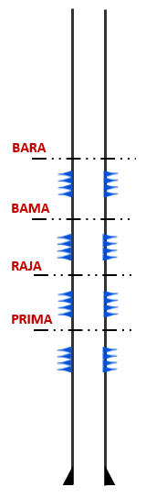
Figure 8.1 Development Plan Alpha-07
Production Forecast
The production forecast for Alpha-07 was conducted using an analog well approach through Decline Curve Analysis (DCA). The analog wells selected for this study include Alpha-01, Alpha-02, and Alpha-05, which are located within the surrounding area and exhibit similar reservoir characteristics.

Production data from these analog wells were subsequently normalized to establish representative production trends for predicting the production performance of Alpha-07. The normalized production profiles were used as the basis for generating production forecasts and evaluating the expected well performance throughout its productive life.

Figure 8.2 Production Forecast Alpha-07

Figure 8.3 Water Cut Forecast Alpha-07

Reserve Estimation
Furthermore, forecast validation was performed to ensure consistency between the predicted production behavior and the performance of the selected analog wells. A summary of the production forecast and reserve estimation results is presented in the following section.

Figure 8.4 Initial Production Validation Alpha-07

Figure 8.5 EUR Validation Alpha-07

Based on the base case estimation, Alpha-07 is projected to achieve an initial production rate of 132 BOPD. In addition, the Estimated Ultimate Recovery (EUR) is estimated at 156 MBO.

The reserve estimation results indicate that the development of Alpha-07 has favorable production potential and is expected to contribute to increased hydrocarbon recovery within the proposed development area

Table 8.4 Production and Reserve Summary
 | P10 | P50 | P90
IP, BOPD | 106 | 132 | 158
FLUID, BFPD | 2000 | 2000 | 2000
WC, % | 95% | 93% | 92%
1st Decline | 105% | 105% | 105%
2nd Decline | 20% | 20% | 20%
Add Reserve, MBO | 122 | 156 | 190

- PRE-EXECUTION MILESTONES & ROADMAP TO SPUD

- Gate 2 Readiness Timeline:
Gate 2 marks the transition from Project Initiation (Gate 1) to Detailed Engineering and Execution Preparation. The following timeline is structured as a backward-planned roadmap from the target spud date of Q4 2026.

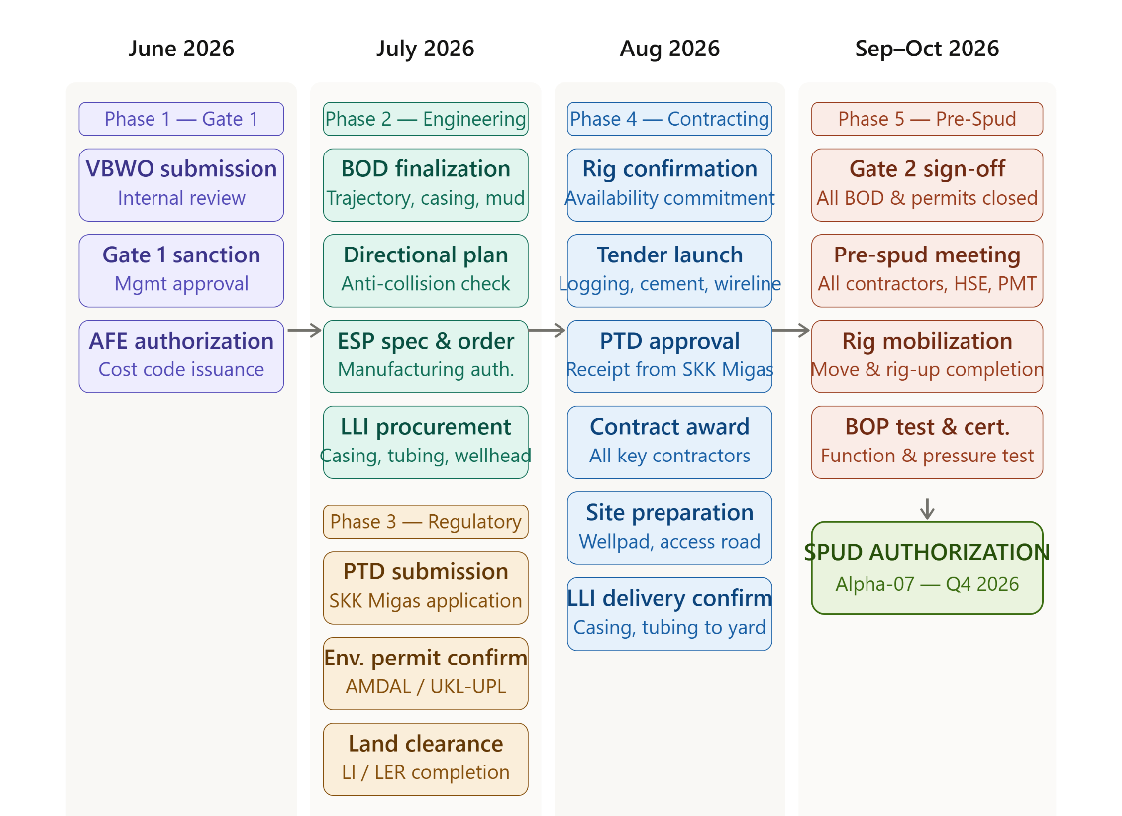

Figure 9.1 Timeline roadmap Alpha-07

- Proposed Spud-In Target Date:
Q4 2026 — October 2026 (Target: 1 November 2026)

SIGN-OFF & PROJECT SANCTION PAGE
This document is submitted by the Project Management Team (PMT) to secure technical and commercial approval to advance to Phase 2 (Project Planning / Basis of Design):
- Prepared by: [PMT Group 6 Core Energy Solution / Abrar Laylramadhan]
- Reviewed by: [Technical Committee / Abilati Monikha Wulandari]
- Approved for Phase 2 by: Pak Ida Bagus Ari Kresnawan (General Chairman / Management Representative)

